**AMPING MEDICAL ASSISTANCE**

**MONITORING AND NOTIFICATION SYSTEM**

**A Capstone Project**

**Presented to the Faculty of the  
College of Engineering and Technology Education**

**HOLY TRINITY COLLEGE OF GENERAL SANTOS CITY**

**General Santos City**



**In Partial Fulfillment of the Requirements for the Degree**

**BACHELOR OF SCIENCE IN INFORMATION TECHNOLOGY**

**by**

**AIMEE LAURENCE CANDO**

**BENHUR L. CARIAGA**

**ANGEL KATE P. HINOCTAN**

**OCTOBER 2025**

**College of Engineering and Technology Education**

**Holy Trinity College of General Santos City**

Fiscal Daproza Avenue, General Santos City

Philippines

________________________________________________________________

APPROVAL SHEET

This capstone project, **“AMPING MEDICAL ASSISTANCE MONITORING AND NOTIFICATION SYSTEM”**,prepared and submitted by **AIMEE LAURENCE CANDO, BENHUR L. CARIAGA, and ANGEL KATE P. HINOCTAN**,has been examined and is hereby recommended for acceptance and approval.

**MERIDEL C. EJUSA, MIT**

**Adviser**

________________________________________________________________

**PANEL OF EXAMINERS**

**LEONILA R. JUANATAS, MIT**

**Chairman**

**RICHARD B. DEMONTEVERDE JAMES BILL C. LABIS**

**Examiner Examiner**

Accepted and approved in partial fulfillment of the requirements for the degree Bachelor of Science in Information Technology.

**CHARISSE S. RONQUILLO, MIT**

**Dean, CETE**

ABSTRACT

The AMPING Medical Assistance Monitoring and Notification System is a web-based computer system for the program of the City Mayor’s Office of General Santos, called the “Auxiliaries and Medical Program for Individuals and Needy Generals” (AMPING), within its office. The system intends to automate the program’s medical assistance application process and digitize the data of the program’s employees and applicants by implementing into the system the following features: data management, system reporting, role-based access control (RBAC), and short message service (SMS) notifications. It is designed to help reduce the dependence on searching and retrieving physical documents on the side of the employees, the administrative program head and non-administrative staff members, and to help deliver information by means of text messages to the applicants. Working under the principles of e-government and e-governance, the system covers AMPING-related matters, such as medical-service-assistance-type application processes and program funding status updates.

**Keywords:** *Medical Assistance, Monitoring, Notification, E-Government, Automation, SMS*

ACKNOWLEDGMENT

The goals of this study have been complicated and difficult to be reached in reality, to say the least. The contributions from people involved in this study have made our study progress in less difficult ways. We are thankful to them for helping us in different ways to make this capstone project possible to be developed and realized.

To **our Almighty** **God**, we would like to thank Him for being with us always, providing us with guidance and help throughout the entire process of this study. As we feel His presence, we gain some strength, fulfilling what is needed to be made and done, and moving on, going on, moving forward, and looking forward in life positively.

To **our families**, their constant love and support have helped us progress and eventually complete this capstone project. Special thanks to **Cando Family**, **Cariaga Family**, and **Hinoctan Family**. They keep our hopes high and fire burn brightly as we go through this journey. We value their contributions. We are thankful for them.

To our thesis Adviser, **Prof. Meridel Ejusa**, we thank her for teaching and guiding us in preparation of making our capstone project. Her encouragement and understanding on our needs helped us keep ourselves on track and achieve our goals. We value her commitment to direct us within the process to success.

To the dean of the College of Engineering and Technology Education (CETE) department, **Prof. Charisse Ronquillo**, we thank her for making us make our capstone project work better with her support and feedback that we take into account. Her leadership has given us resources and direction that keep our study aligned with high academic standards of the educational institution. Her respectfully honest critique has contributed for us to successfully complete our capstone project.

To the **CETE department**, thank you for giving us with resources we need to complete this study. Also, to the **employees** of the **Auxiliaries and Medical Program for Individuals and Needy Generals** (**AMPING**), we thank them for allowing us to conduct our study and propose our system within their office. Their cooperation and openness during the evaluation of the system greatly contributed to the success of our research. Moreover, their honest feedback and reaction during and after the system evaluation inspired and motivated us to further improve our work and strive to present a more effective and dependable system. Their involvement has been truly vital to the progress and completion of this study.

To **all the respected individuals** who have supported and guided us throughout this journey, we express our heartfelt gratitude for your roles in realizing this capstone project. This would have been not possible without your compassion and contribution.

TABLE OF CONTENTS

TITLE PAGE i

APPROVAL SHEET ii

ABSTRACT iii

ACKNOWLEDGMENT iv

TABLE OF CONTENTS vi

LIST OF FIGURES viii

CHAPTER I 10

Project Context 10

Statement of the Problem 13

Objectives of the Study 13

Scope and Limitations of the Study 14

Significance of the Study 15

Definition of Terms 17

Technical Terms 17

Operational Terms 19

CHAPTER II 21

Related Literature 21

Related Systems 27

CHAPTER III 31

CHAPTER IV 34

Software Development Life Cycle Model 34

Requirements Analysis 35

Context-Level Data Flow Diagram 36

Level 0 Data Flow Diagram 37

System Design 39

Use Case Diagram 40

System Architecture 41

Conceptual Framework 42

Organization’s Operational Framework 43

Project In-Scope and Out-Scope 44

Story Board 46

Data Model 47

Entity Relational Diagram 48

Data Dictionary 49

Implementation 61

Testing 62

Data Analysis Plan 62

Implementation Plan 66

Deployment 67

Maintenance 68

CHAPTER V 69

CHAPTER VI 73

REFERENCES 76

APPENDICES 80

APPENDIX A 80

APPENDIX B 121

APPENDIX C 124

APPENDIX D 126

APPENDIX E 129

APPENDIX F 130

APPENDIX G 131

CURRICULUM VITAE 133

LIST OF FIGURES

Figure 1 – Iterative Waterfall Model34

Figure 2 – Context-Level Data Flow Diagram 36

Figure 3 – Level 0 Data Flow Diagram37

Figure 4 – Use Case Diagram40

Figure 5 – System Architecture41

Figure 6 – Conceptual Framework42

Figure 7 – Organization’s Operational Framework43

Figure 8 – Story Board46

Figure 9 – Entity Relationship Diagram48

CHAPTER I

**INTRODUCTION**

Project Context

Health is one of the most important human rights, but many people cannot access healthcare because of their financial limitations. In General Santos City, Philippines, the local government established the Auxiliaries and Medical Program for Individuals and Needy Generals (AMPING) in October 2018 to offer medical and funeral assistance to its low-income city residents. The program releases guarantee letters (GLs) to the qualified clients. The GLs work as official authorization documents to be given to hospitals, pharmacies, and funeral service companies, the program’s partners, for the government to act on behalf of the applicants to pay for medical and funeral services. The medical part of the program covers hospital bills, medical prescriptions, laboratory tests, diagnostic tests, hemodialysis, and blood requests. This ensures that the applicants and patients receive medical services without financial stress.

In order to receive assistance from the AMPING, an applicant has to visit the AMPING Office, located at GSC Training Center beside Post Office, Roxas Avenue, to get, write, and submit an application form of the program, and the documents required for a type of assistance, chosen by the applicant, to a program staff member, an evaluator, who conducts interviews with every applicant and the

checks for eligibility if the information on the application form and required documents given by a are complete and valid. After the evaluation, if the applicant is deemed eligible, another staff member, an encoder, then puts and stores the data of the submissions to spreadsheet files via Microsoft Excel. After that, the encoder also calculates the monetary amount of assistance to provide based on the criteria in the chosen assistance type and specific tariff list in it, and creates and prints a GL for the program head, or its representative if not present in some days, to evaluate the application entry for the second time to sign the GL, if approved. The GL is then given to the applicant to hand it over to certain individuals to deliver the services. For example, an applicant gives the hospital bill receipt and the GL to a hospital cashier.

The researchers have discovered problems currently affecting the AMPING Office. First, the AMPING employees maintain their records through paper-based documents and logbooks posing risks of damage or loss. Finding and retrieving information of specific applicant profiles and their application entries have to last longer for the staff to do. The employees heavily depend on Microsoft Excel, which is used to manage the AMPING-related data, but becomes more difficult to secure and manage as the amount of data grows, because there are 36,590 clients given with assistance from January to November 2024 based on a post of the official General Santos local government Facebook page named LGU GenSan: TATAK Heneral (2024). Second, the employees struggle to record and monitor the remaining budget and the number of released GLs, causing overspending and supplementary budget implementation, earlier than expected. Third, the evaluation process for every application entry is conducted twice and separately. in some cases, the evaluators might approve of the entry but the program head, with its corresponding GL, might reject it. Fourth, some applicants forget when they can apply again for assistance from the program, resulting in untimely visits to the office. These problems cause wasted time and resources.

The researchers present a proposal about a computer system to address these problems, the AMPING Medical Assistance Monitoring and Notification System. It is an online web-based platform accessible through the internet for the AMPING Office. It allows the encoders to put application entry data into the system, calculate the monetary amount of assistance to provide according to the criteria in the chosen assistance type and the tariff list, generate guarantee letters written in a template preset and also comes with SMS (short message service) technology for the AMPING staff, to send text messages to the applicants about their application entries with reapplication dates. It also allows the program head, the administrator of the system, to implement role-based access control (RBAC) by assigning access roles such as encoders to staff member as well as printing guarantee letter and view summary of reports for GL releases, remaining budget, and operating expenses.

Statement of the Problem

The AMPING is a governmental program in General Santos, Philippines offering medical and funeral assistance to low-income city residents. It faces the challenges of manual record keeping, budget and guarantee letter monitoring, and applicant communication. Specifically, this study seeks to answer:

1. How can each applicant be assured of fair and transparent medical assistance based on the set tariff list for each type of assistance?
2. How can the staff members monitor the remaining fund based on the issued guarantee letter that cause overspending?
3. How can applicants avoid from wasting time going to the office to reapply, only to be told that they must wait three months before they can apply again?

Objectives of the Study

The main goal is to design and develop the AMPING Medical Assistance Monitoring and Notification System to lessen manual processing, improve data transparency and applicant communication. Specifically, the study aims to:

1. Automatically calculate the monetary amount of assistance based on the tariff lists in every medical assistance type.
2. Monitor the remaining budget and guarantee letter releases to prevent overspending.
3. Notify the applicant about when they can reapply for the type of assistance that they need.

Scope and Limitations of the Study

The study on the AMPING Medical Assistance Monitoring and Notification System would cover the system’s journey. The researchers have identified two primary users for the system: staff members (encoders), and the program head (system administrator). The system would cover the applicant profile and application entry recording, monetary assistance provision amount calculation, the AMPING budget and guarantee letter (GL) release monitoring, and system report generation for the following medical types of assistance: hospital bills, medical prescriptions, laboratory tests, diagnostic tests, hemodialysis, and blood requests. The system is an online web-based platform that can be accessed through web browser with an internet connection, and with SMS feature to communicate to the contact numbers of the applicants on their application entry details and reapplication dates. The web-based platform also comes with a set of interactive visuals with different widgets and pages that are easy to understand and use. The program head can assign the encoder role to authorized staff members to manage system access. The researchers have set limitations for this study. The system would not initially include funeral assistance, until it is proven effective for the medical assistance types in operation. The SMS feature in the system would not allow the applicants to reply to the system’s text messages. The system would also not come with new hardware and integration with the program’s partner organizations, including the billing processes. The researchers would not cover the program policy and criterion alteration, and telecommunication network control.

Significance of the Study

The AMPING-MAMANS carries significance for the AMPING program, its stakeholders, and General Santos. The study seeks to improve the program’s engagement with applicants, increase efficiency in its office operation, and promote transparency to serve medical assistance to the applicants by the system’s role-based security, automation, and communication. Here are the following people and entities that would benefit from this system.

**Employees.** The system allows the program head and staff members in doing their roles more efficiently and clearly by implementing RBAC; automating data creation, update, search, and retrieval; and providing intuitive and system reports, which help them monitor their performance and program operations, communicate with the applicants by means of the SMS technology, and control their ways to spend the original and supplementary budgets given yearly the local government of General Santos for the services of AMPING.

**Applicants.** The system allows them to get intuitive text messages in SMS notifications, about their profiles, application entries, guarantee letters (GLs), and exact reapplication dates to work around the possible forgetfulness and memory mismatch in some of them, reducing the chance of repetitive office visits.

**AMPING Office.** The system is placed inside a secure room within the locale of the research. The higher-up employees, such as the program head, can get, read, and understand digital and printed system records and reports, which are presented intuitively and statistically, in applicant profiling and application, GL releasing, and program budget and expense monitoring.

**Local Government of General Santos**. The system provides support in the performance the government employees working for the AMPING, with the sense of accountability and transparency, inspiring other government employees working for other local government agencies, programs, and initiatives in the city and also in other cities in the Philippines to do in similar ways by implementing future computer systems similar to the proposed one. The system also helps the officials who work for the Local Government Unit and Sangguniang Panlungsod (City Council) of General Santos perform and understand in better ways to make plans and decisions based on the information pieces from the reports generated and printed by the system, including the ones about how the AMPING operates, how the financial resources for the program is used, and who has been served with assistance from the program, improving the program itself.

**Holy Trinity College of General Santos City**. The study serves as an example for current and future students in the educational institution to take the courses related to computing or government, inspiring similar theses, capstone projects, and other research studies to be conducted in the future.

**Future Researchers**. The study helps the researchers of the proposed system apply their knowledge and wisdom to it, and helps the researchers of the future studies have this study serve as one of their references to plan for and then carry out their system implementation and/or systematic investigation.

This study contributes to the research on the concept of the governmental use of digital technology. It also supports the AMPING’s mission to provide more accessibility to medical services to the residents of the city.

Definition of Terms

This section is for the readers to understand the context of the study.

Technical Terms

**Automation** refers to a method where performing tasks involves minimal human intervention, letting technology take over complex tasks to achieve efficacy and efficiency. With this, the system can improve the operation of the AMPING by monitoring the AMPING-related data and sending SMS notifications.

**Role-based access control** (**RBAC**) is a security feature that controls who can do what in a computer system by assigning specific permissions to roles for every type of user. The system allows the program head, the system administrator, to assign and reassign every staff member present in the AMPING Office.

**Short message service** (**SMS**) is a communication service for mobile devices to send and receive text messages. The AMPING employees use the system to deliver text messages about application entry updates to applicants.

**Notification** refers to an instance of being given with or giving a report of an occurrence triggered by user actions. The system sends SMS notifications that contain text messages about application entry updates to applicants.

**Application programming interface** (**API**) is something that allows a computer system to connect, communicate, and interact with other platforms, services, and computer systems. To reduce development time, the researchers would not do hard coding from scratch, enabling SMS feature in this case, in programming the system. The researchers would use an SMS API to allow the system to send SMS notifications to applicants.

The **model-view-controller** (**MVC**) approach is in system architecture guiding the researchers for faster development and better operation in the AMPING Office. The **model** handles how data would be manipulated and moved around, the **view** handles how the system displays user interface elements, and the **controller** handles user requests and their corresponding system responses.

**Object-relational mapper** (**ORM**) is a tool using codes in a single programming language to be converted to codes in a database language, such as Structured Query Language (SQL). It reduces development time and improves system operation by reducing manual database programming, and letting the said tool do the heavy lifting. The researchers would implement a framework for the system supporting the MVC approach, having ORM for its model component.

**Network stability** refers to a condition where a telecommunication service has a consistently reliable connection. This provides the system with proper operation and enables delivery of SMS notifications without much delay.

**Electronic government** is about the use of digital technology by governments to deliver information and services to citizens. In General Santos City, AMPING staffs utilize the system to enhance the delivery of assistance, while applicants receive timely updates through SMS notifications.

**Electronic governance** is about how the use of digital technology can change how the government operates and its citizens participate with it. The system has the guarantee letter monitoring feature, promoting transparency in order for the residents to see the truthfulness of AMPING.

Operational Terms

**Auxiliaries and Medical Program for Individuals and Needy Generals**, the **AMPING**, is a government program in General Santos, Philippines offering medical and funeral assistance via guarantee letters to city residents.

The **Generals** refer to the residents of General Santos. They are the ones to use the system, mostly as applicants and some as employees of the AMPING.

**Eligibility** refers to the condition wherein, upon evaluation, an applicant meets the requirements, based on completeness and validity, to get an assistance type corresponding to the requirements. This is an important factor for the AMPING employees to input and process client profiles and application entries.

**Tariff lists** refer to lists of standardized assistance money amount ranges for different types of assistance. The system allows GL operators to calculate the monetary amount of assistance, based on the criteria to satisfy to obtain the type of assistance chosen and the amount needed by an applicant.

A **guarantee letter** (**GL**)refers to a written document that states that the local government of General Santos City will provide the amount of money needed for paying services of the program partner organizations. GLs are given to the applicants eligible for their chosen assistance types, serving as records verifying that they have received assistance. The system can automatically generate, print, and monitor GLs to maintain data accuracy.

**Reapplication date** refers to the date 90 days after the current date, serving as the waiting period set by the AMPING for every applicant to apply again after having an instance of the program’s delivery of assistance in effect.

A **patient** refers to someone who is usually a relative or fellow member of the family of a client, and the one to actually get the program’s benefits via GLs.

An **applicant** refers to someone in AMPING acting as a representative of a patient. Applicants are the ones who go through the application process to receive the GLs. Some applicants are also patients themselves. The system would maintain database for all applicant-related data, including details of their application entries. The clients would receive SMS notifications from system related to the data.

A **staff** refers to someone working for the AMPING, covering the program head and employee members. They can access the website of the system.

The **program head** is the administrator of the system assigning and reassigning role to every **staff member**, referring to a non-administrator staff assigned to one of the roles: evaluator, encoder, GL operator, and SMS operator.

An **evaluator** refers to a staff member who reviews client application entries to determine their eligibility for assistance. The system would help the evaluators make unbiased choices through fair decision-making.

An **encoder** refers to a staff member who put the application entry data to the storage in the AMPING office. The system would help the encoders place raw applicant-related data to the system more efficiently.

CHAPTER II

**REVIEW OF RELATED LITERATURE AND SYSTEMS**

This chapter presents studies made by other researchers and thought to build and strengthen the foundation of this project to design, develop, and implement the system. The studies have been considered and curated by the researchers of this study for their relevance to this project, and also presented in a way for readers to be able to understand.

Related Literature

The AMPING Medical Assistance Management System is linked to the concepts of electronic governance and electronic government, using information technological tools to deliver public services, as well as their advantages and challenges when being used with citizen engagement.

Shaikh et al. (2016) compared manual and electronic public service deliveries in Pakistan and look into the idea whether e-governance can increase accountability, transparency, and effectiveness. They found out that electronic systems speed up service delivery, limits bureaucratic inefficiencies, political interference, as well as enhancing transparency and accountability. However, e-governance implementation is restricted by poor ICT infrastructure, poor political management, and institution resistance. They propose positive institutional and cultural changes with high level of acceptance to e-governance.

Pabatang-Hussien (2023) studied e-governance in two highly urbanized cities in northern Mindanao, Philippines: Cagayan de Oro and Iligan. The researcher shows four e-governance service forms: government to citizens (for general public), businesses, employees (for government workers), and government (between government offices), as well as the acceptance of technology in organizations (institutions) in environments (cities). The researcher found out that digital tools have significantly improved the level of accessibility, efficiency, and responsiveness of the governmental institutions in both cities to deliver their public services to their citizens. This finding is also supported by Andaya et al. (2025), who also presents multiple Philippine studies, which bring more findings about the concepts used by the AMPING Medical Assistance Management System, to be discussed in the following paragraphs.

Palma et al. (2023) examined the e-governance conditions in five major cities in Luzon (Manila, Taguig, Pasay, Makati, and Quezon) and one major city in Mindanao (Davao). The researchers show three e-governance service forms: government to citizens, businesses, and government. They found out that people in these cities frequently use four communication channels: web portals (official websites), mobile applications, web applications, and social media. These wide variety of communication channels resulted in the improvement of delivery, transparency, and engagement in all e-governance service forms.

Moreno and Barrios (2024) investigated e-government projects in the city of Zamboanga, focusing on how well they are working in dealing with challenges in the local government of the city, such as in transactions and processing in money, data and other materials, and service transparency of the government. They found out that these projects decreased processing times, and increased transparency and efficiency in government institutions.

Kiram et al. (2025) looked into the digital technological conditions in the province of Sulu in Mindanao. The researchers focused on how data is handled with privacy and security that promote trust, and kept safe from risks and threats that cause distrust. They found out that e-government provides opportunities to improve accountability and transparency in the government side, and to improve reception of public service in the citizen side, because of the firm belief of the citizens in their positive expectations for the government and then fulfillment of these expectations by the government.

The implementation of digital technologies in governments is not without imperfections. Significant challenges related to management and security are often overlooked in adapting computer networks to improve efficiency of operation and communication. Wrongful use and poor management on e-government systems can make these systems vulnerable to cybersecurity issues and other problems, such as misunderstandings, unauthorized accesses, data breaches. Therefore, digital tools, e-government systems for governmental organizations in this case, can work as benevolent people intend if there are people really taking care of their management and security (Moussa, 2016).

A study looked into the preparedness and challenges in the e-governance implementation in Zamboanga City. Moreno and Delos Reyes-Urmanita (2024) investigated citizen engagement, organizational capability, digital infrastructure and literacy in terms of e-governance. The study pointed out that many LGUs struggle with problems in digital technology adoption, due to underdeveloped ICT infrastructure, underwhelming implementation, and a lack of human resources, resulting in difficulties in delivering public services effectively. The study found out that although there is a significant stimulation to create policies dealing with digital technology, digital illiteracy and resource shortages are the primary problems holding the actual implementation back.

A study investigated HealthCare.gov, a website made by the government of the United States for helping people search and sign up for health insurance, focusing on its success or lack thereof. Anthopoulos et al. (2016) looked into the challenges in the aspects of architecture, implementation, and operation of the website. The researchers found out that the website’s slow and overwhelmed performance, and mismatch between design and practicality contribute to user expectation unfulfillment, along with its authorities’ lack of transparency.

Ejdys et al. (2019) examined how public trust in e-government solutions in Poland is influenced by the security and danger perceptions. Their study is about knowing how risk-related concerns on online government services can impact the decision-making of people to whether to use those services or not. They argued that, despite growing use of digital technologies in governments to improve the delivery of their service, people hesitate because they perceive these as having exposure to likely harm and having lack of protection. This study pointed out a problem that lack of trust of citizens in governments can make adoption of digital tools more difficult to achieve. The study found out that, to a great extent, indeed perceived risks, such as stealing and misusing sensitive data, can erode the foundation of trust of citizens in governments, while stronger security and more open transparency can reinforce this trust foundation.

Munyoka and Maharaj (2019) examined in Zambia and Zimbabwe on how people’s use of e-government services can be affected by their views on trust, privacy, security, risk, and optimism bias (the tendency towards expecting to experience fewer negative events and more positive events). The researchers pointed out that people adopted to use those services in these countries remains low in number, despite significant investments in digital public services, due to enduring concerns on security breaches and privacy risks. The study’s findings showed that the low level of people’s trust in using e-government services is because of low level of awareness on privacy and security; while optimism bias lessens the negative impacts of these perceived risks, this is not enough to overcome the doubts and suspicions completely.

Several research studies in the literature related to e-government and e-governance support the use of digital government solutions by demonstrating improvements in public service delivery in terms of accessibility, engagement, transparency, accountability, efficiency, and excellence. Meanwhile, several other studies focus on challenges. They presented the arguments that lack of interest, management, and resources for operating computer systems, expanding ICT infrastructure, and fulfilling people’s needs can result in easy commitment to cybercrimes (such as cybersecurity breaches and data theft), low service delivery quality, and diminished trust of people to use the computer systems.

The studies supporting the proposed system for the AMPING provide its researchers helping in achieving the goal to decrease processing times and operation errors in the program office as well as the local government of General Santos, whereas the studies opposing the system remind the researchers to pay attention to the system security and training for its target users. With these considerations in mind, the system is truly effective if the users believe, confirm, and know that it is effective. They might reject it if they do not trust it.

Despite the valuable insights presented by the research studies in the literature that support and oppose the concepts, the demographic factors, such as age groups (for example: 1–7, 8–17, 18–39, 40–59, 60+) and/or generational groups (for example: Generation Z, Millennials, Generation X, Baby Boomers, Silent Generation), which can affect in adopting digital government systems, are explored and addressed by only a few research studies, such as the research studies of Kiram et al. (2024) and Ejdys et al. (2019). Several presented studies have lack of focus on how understanding and attitude towards digital technology can vary in every group of people by age or generation. Not considering these factors can pose the risk of implementing computer systems that favor one group or a few groups over others, causing digital divide. For example, younger users might prefer accessing websites or applications and reading information on there through mobile devices, while users of older generations might find these actions difficult to do. Younger people desired faster public services, while some older ones avoided digital tools due to fear of scams. By examining and considering how General Santos residents of different age or generation groups use the proposed system, the researchers look forward to close this gap.

To encapsulate, the literature showed that, with careful planning, digital tools can change how government services are delivered. The AMPING Medical Assistance Manage System would follow the lessons from the literature, notably the influence of age and generation in technology, to fulfill the gap. This project would be inclusive for Generals, as many as possible, ensuring great, beneficial impact, opening the door for future similar initiatives in the Philippines.

Related Systems

The AMPING Medical Assistance Management System can be analyzed and defined in its key features to compare it other existing computer systems: document management, system reporting, RBAC, and SMS.

In the governmental aspect of internal affairs, Rodriguez III et al. (2024) developed a cloud-based document management and monitoring system named eDALAYON, intending to address paper-based document management challenges in the Negros Occidental branch office of Department of the Interior and Local Government (DILG). The system implements document data backup onto the Internet (the cloud) and retrieval in the system, RBAC, and automated system reporting. The researchers did not disclose any of the tools they used to develop the system, neither programming languages, frameworks, nor others, from code editing to the system components.

Two capstone projects from Bacolod, Negros Occidental, Philippines, featured in Capstone Guide (2025), a website, are named the Patient Scheduling and Program Management System and Barangay Profiling System. The first computer system automates much of the processing in healthcare appointments and resource management in a health center in Barangay Granada by reducing manual processing delays, and improving medical data recording and resource distribution. Meanwhile, the second one helps in making decisions and digitally manages resident profiles and barangay resources in Barangay 17 by real-time data updates and automated report generation. Both systems use MySQL for database management and PHP for the backend development, but the Patient Scheduling and Program Management System showed that it uses HTML, CSS, and JavaScript for the frontend development.

In the field of law, Grepon (2021) developed a computer system named “Web-based Case Docket Information System” (WCDIS) to address the manual court case management inefficiencies at Regional Trial Court Branch 23 in Cagayan de Oro, Philippines. The study presents a fire incident in January 31, 2015, which lasted for about five (5) hours, and caused destruction in the city’s Hall of Justice building, killing two individuals, a court employee and a security guard, and also losing physical case dockets to the fire. Case dockets are crucial in legal court proceeding because they contain documents of legal cases. The project intends to automate legal case monitoring, improve data security through cloud storage, and speed up report preparation. WCDIS is made with the use of HTML, CSS with Bootstrap framework, and JavaScript in the frontend; and PHP, Apache, and MySQL in the backend.

In Southern Philippines Agri-Business and Marine and Aquatic School of Technology (SPAMAST), in Malita, Davao Occidental, Philippines, Rellon et al. (2020) made a web-based document tracking system with barcode technology and SMS notification to modernize document tracking. The study aims to simplify tracking operations by human involvement for fast document status and location detection. Aside from barcode scanners, the system is made using Visual Studio, designed its website using plain CSS, managed its database using MySQL, and integrated the SMS feature into the system with the use of Twilio.

In Tarlac Agricultural University (TAU), in the eponymous province in the Philippines, Lingaya (2019) developed a computer system to meet the needs of the higher educational institutions (HEIs, colleges and universities) in tracking documents, with barcode scanning feature. The system uses HTML for the frontend, plain PHP for the backend, and MySQL for the database.

In the University of Northern Philippines (UNP) in Vigan, Ilocos Sur, Philippines, Castro et al. (2022) have made a web-based document tracking system named DocTrack. It intends to manage document transactions in the educational institution through a website, speeding up operation and reduces maintenance expenses simultaneously with security controls for data protection. It also has the SMS feature where registered users get text messages from the system about the information of documents they intentionally or unintentionally did not sign. The study disclosed some of the tools in the making of the system, specifically PHP with CodeIgniter framework for the frontend and the backend of the system, and MySQL for managing the database of the system. These research studies featuring their respective systems have shown positive results from their respective target users in their respective locales with the use of some features to be used by the proposed system.

PHP for backend operation and MySQL for database management are commonly used for document management in most of the featured computer systems related to the proposed system. RBAC feature is used by eDALAYON (Rodriguez III et al., 2024). The SMS is important being part of in some systems, such as the research studies in SPAMAST (Rellon et al., 2020) and DocTrack (Castro et al., 2022). The existence of these tools and features in these systems support the proposed system, proving themselves doing their noble goals. In light of these studies, the researchers would develop and operate the proposed system with these specific features, while accommodating their target users, and closing the gaps of uncoordinated monitoring and notification in the AMPING.

CHAPTER III

**TECHNICAL BACKGROUND**

**Visual Studio Code** (**VS Code**) is the code editor the researchers would use to create, view, and modify the source code of the system.

**Hypertext Markup Language** (**HTML**) is the language they would use for the content and structure definition of the website of the system.

**Cascading Style Sheets** (**CSS**) is the language they would use for the presentation design of the website, making its webpages good-looking.

**Bootstrap** is a CSS framework they would use for its ready-made style component collection for things such as pre-need buttons, cards, and others.

**Font Awesome** is an icon library the researchers would use in the system for their desired icon that do not exist in the official icon library of Bootstrap.

**JavaScript** (**JS**) is the language they would use to make the website interactive by manipulating data in the frontend before saving the changes by the backend, through the server and database of the system.

**Node.js** is the runtime environment the researchers would use to enable the **Node Package Manager** (**npm**) to install, update, and handle necessary Bootstrap and Font Awesome packages in “**node_modules**” folder of the system.

**Laravel** is a PHP framework following the Model-View-Controller (MVC) architecture applied by the researchers in speeding up system development. The Model will work with the data and communicate with a database with the use of Eloquent ORM, View will render the content because it will run the mix of PHP and HTML codes through Blade, and the Controller will process user requests and moves the appropriate responses. The following are Laravel packages to use:

**IDE Helper** generates helper files enabling VS Code to recognize PHP functions in Laravel and provide accurate coding autocompletion.

**Laravel Debugbar** enables the researchers to view the analytics of the computer system for easier debugging or removal of erroneous source codes.

**Laravel Scout** implements data search, filtering, and pagination.

**Laravel Tinker** can convert plaintext passwords into hashed passwords.

**Laravel Permission** implements RBAC, allowing the administrator system user, the program head, to manage user roles and permissions.

**Laravel Excel** can create Microsoft Excel files with HTML and PHP codes to be used for the system’s pages with data tables, such as for tariff list versions.

**Laravel Snappy** can generate PDF files with HTML, CSS, and PHP codes to be used to generate the AMPING’s guarantee letters and the system’s reports.

**wkhtmltopdf-windows** utilizes Qt WebKit and Microsoft Windows binaries to enable Laravel Snappy to convert HTML and CSS codes to PDF files.

**Livewire** serves as a companion to JavaScript for source code files that need live CRUD operations to work as intended, without page reload to update.

**Composer** is a PHP package manager they would use to install, update, and handle files related to necessary Laravel packages in “**vendor**” folder of the system. It can be manipulated through the command-line interface (CLI) of VS Code for the package manager to do what it is designed for.

**Apache** is a software delivering webpages to web browsers using the Hypertext Transfer Protocol (HTTP). This would be used by the researchers to manage the operations in the server of the system.

**MySQL** is one they would use this to manage the database of the system. This arranges data in tables, easing the data searching, and connects related pieces of data between different tables. It makes data monitoring in the system less difficult, and information readily available and visible for the system users.

**phpMyAdmin** is an administration tool written in PHP for relational database management systems, such as MySQL. It helps the researchers view and manipulate the content and configurations presented in the database of the system, with the help of its graphical user interface (GUI). This also gives the AMPING employees full control over AMPING-related data.

**GitHub** is a developer platform that enables the researchers to research for suitable packages for Laravel, share the system among them and manage its version online; and for the AMPING computing professionals to do the same.

**Render** is a cloud application platform to deploy the system online.

**TextBee** provides an SMS API for the researchers to allow the AMPING staff, to deliver automated text messages to applicants for application details, promoting transparency between the staff and applicants and reducing instances of untimely visits for supposed reapplications.

CHAPTER IV

**DESIGN AND METHODOLOGY**

Software Development Life Cycle Model

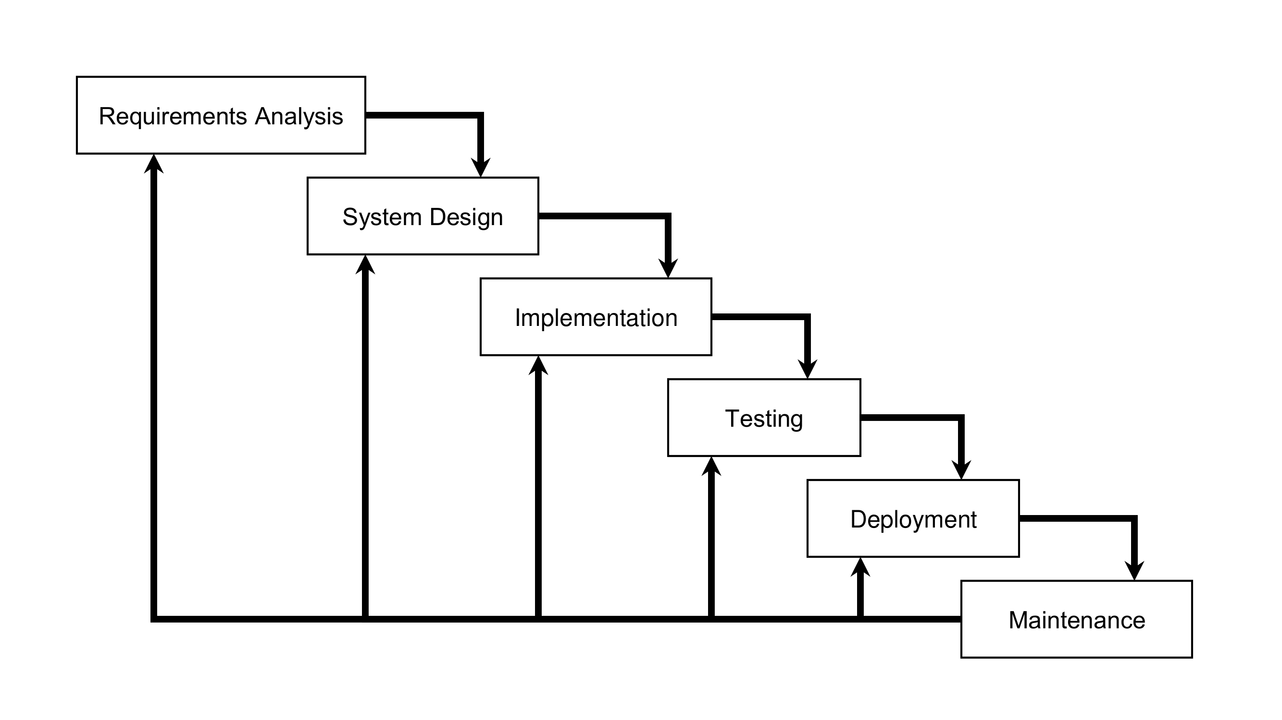This chapter presents how this study and its project, AMPING Medical Assistance Monitoring and Notification System, would be made by reviewing and learning the methods (ways to do the pieces of work in conducting the study and developing the project, or tasks), practices (activities to do the tasks), procedures (steps to do the tasks), and rules (recommended or required guides to do the tasks). After these, the researchers would make, decide, and perform the plans related to what they have reviewed and learned to do the tasks. The plans would be presented and discussed here, including the diagrams, to understand how the researchers would conduct the study and develop the project.

Figure 1 – Iterative Waterfall Model

The figure above presents the **Iterative Waterfall Model** (**IWM**) as the systems development life cycle (SDLC) methodology chosen by the researchers. They decided to use this approach because it is an enhanced form of the original Waterfall Model (OGWM). The IWM is similar to OGWM but with feedback loops to allow flexibility by going back to phases to find parts of the project process with possible errors, mismatches, and shortcomings, and then to plan for and to carry out necessary corrections, adjustments, and improvements to those parts. The IWM has six (6) phases similar to the OGWM: requirement analysis, system design, implementation, testing, deployment, and maintenance. The IWM makes sure the system is secure enough to handle sensitive data on applicant application entries and remaining funding. Revisiting certain parts of the project process makes sure that the system correctly performs the operations the researchers intend, with the help of reviews and reactions from target users.

Requirements Analysis

To further know and understand the situation in the research locale as of this writing, the researchers made a letter to conduct study in AMPING office to gather information (see **Appendix C** on **page 83**), after that the researchers have visited and observed in the program’s office, especially in the aspect of how it operates. Then, they have conducted interviews there with one staff member about the inner workings of the office (see **Appendix B** on **page 82**), and some clients about their experiences with the program. The observations and interviews are essential in writing this capstone project document, especially in knowing and understanding what are the gaps and other problems that the AMPING needs to solve with the help of the proposed system. The researchers saw that the process for applicant applications was done manually that causes proneness to delays and errors, difficulties in monitoring funds, and the lack of reminders for clients about when to reapply for assistance, causing staff’s overspending and applicants wasted visits. To address these issues, the researchers decided to develop the AMPING Medical Assistance Monitoring and Notification System, designed to securely automate and manage application and funding data, provide user interface to monitor released guarantee letters and available funds, and send SMS reminders to applicants for a smoother and more efficient transaction.

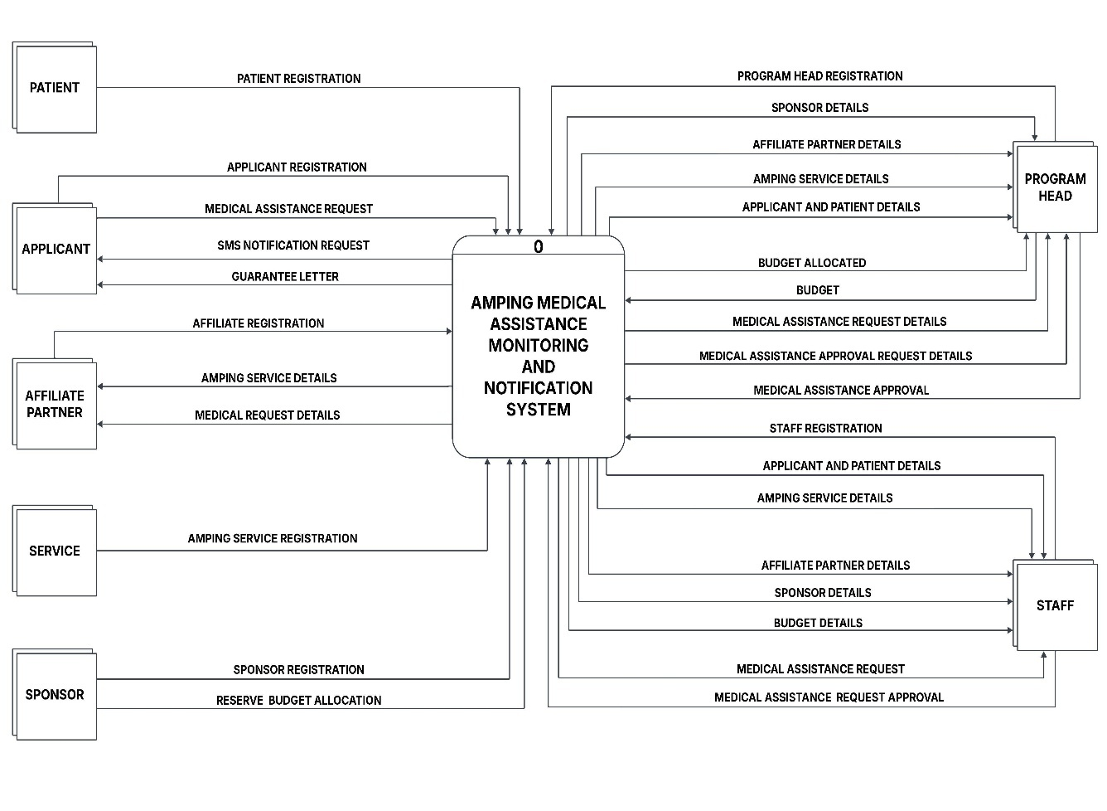Context-Level Data Flow Diagram

Figure 2 – Context-Level Data Flow Diagram

The context diagram of the system illustrates data forms each of its users send and receive to and from the system. Patients and applicants register and request medical help, and applicants also receive guarantee letters and SMS notifications. Affiliate partners and services register and provide medical service details, while Sponsors register and allocate budgets. The staff members are responsible for inputting data and sending approval request for medical assistance. The program head approves or rejects medical assistance request and manage overall system data like budgets, user details, and approvals.

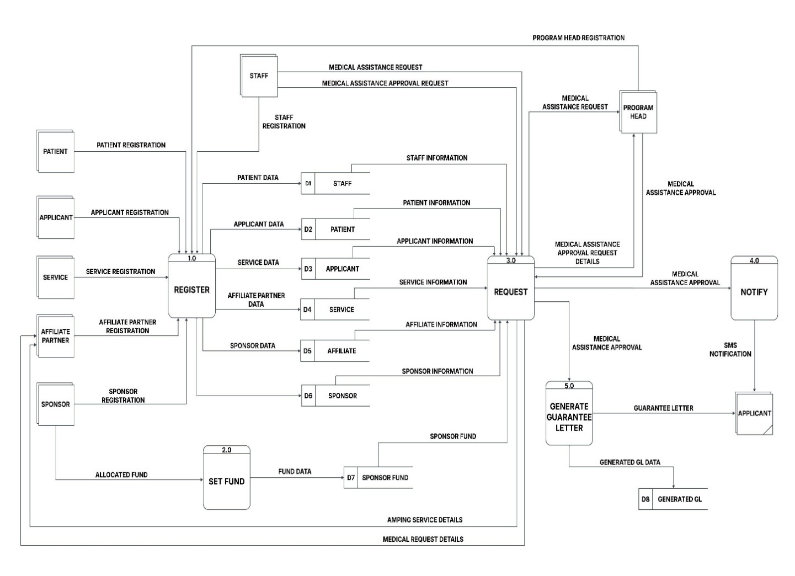Level 0 Data Flow Diagram

Figure 3 – Level 0 Data Flow Diagram

This data flow diagram of the system illustrates the expanded form of the

context diagram, with 5 primary processes and 8 data stores (tables). This is how the program workflow functions with the system. Process 1.0 - Register, different entities like Patient, Applicant, Service Providers, Affiliate Partner, and Sponsor can register their information into the system. Also, Staff and Program Head can register. All this registration is stored in different data stores such as D1 for Staff, D2 for Patient, D3 for Applicant, D4 for Service, D5 for Affiliate, and D6 for Sponsor. In the process 2.0 - Set Fund, a Sponsor can allocate funds, which are then stored as “Sponsor Fund” in D7 for Fund. This fund information is used when requesting medical assistance. Process 3.0 - Request, Applicant can make a Medical Assistance Request, this request uses information about the patients, clients, services, affiliates and sponsors pulled from their respective data store. The Program Head then reviews these requests and provides “Medical Assistance Approval” back to this process. In process 4.0 – Notify, after the Medical Assistance Approval, the system sends out an SMS notification to the applicant as well in process 5.0 – Generate Guarantee Letter, once medical assistance is approved, a Guarantee Letter is generated. This letter data is stored in D8 for Generated GL. After generating the GL, it will be given to the applicant physically.

System Design

The researchers have created plans on how the system would function according to the problems and other requirements in the research locale the researchers have known and understood to address. Before starting the actual programming, they have created diagrams and other illustrations as the plans’ parts and guiding instruments in developing the system properly. They have made the AMPING Organization’s Operational Framework to show the process of assistance application of the program’s office before the time to implement the system (see **Figure 7** on **page 49**); Use Case Diagram to show what actions that the users can do in the system and how these actions connect to different users (see **Figure 4** on **page 40**); Context-Level Data Flow Diagram (DFD) to show how users interact with the system and how they send and receive forms of data from and to other users through the system (see **Figure 2** on **page 36**); Level 0 DFD to show, expand, and explain further the Context-Level DFD, including how data forms are delivered, processed, and stored from and to the system’s database (see **Figure 3** on **page 37**); System Architecture to show the interactions of the system’s components with one another and users (see **Figure 5** on **page 41**); Conceptual Framework to show how user inputs are processed to provide medical assistance, budget monitoring, and notifications with outputs evaluated for continuous improvement (see **Figure 7**6on **page 42**); Entity-Relationship Diagram to present the flow of inputs, outputs and processes that streamline medical assistance, budget tracking and notifications to enhance program efficiency(see **Figure 9** on **page 48**); and Storyboard to show what the graphical user interface (GUI) of the system would look like (see **Figure 8** on **page 46**). These help the researchers imagine the system’s interface appearance and inner workings during development.

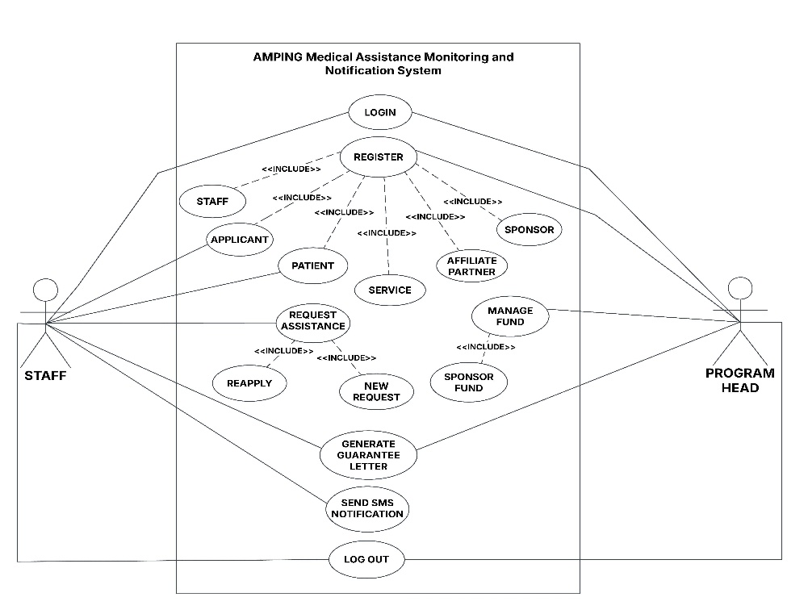Use Case Diagram

Figure 4 – Use Case Diagram

The use case diagram of the AMPING Medical Assistance Monitoring and Notification System shows how each user interacts with the system. There are two main users, the program head and staff members. Both of them can log in and log out of the system. The program head has more access, since they can register staffs, sponsors, affiliate partners, services, applicants and patients. Meanwhile, staff members can only register applicants and patients. The program head is also in charge if managing the funds, including money from sponsors. Staff members can submit medical assistance requests for applicants. After a request is made, the system creates a guarantee letter, which can be generated by either the program head or the staff. Once it has been done, the staff sends an SMS notification to the applicant, reminding them about their reapplication schedule.

Organization’s Operational Framework

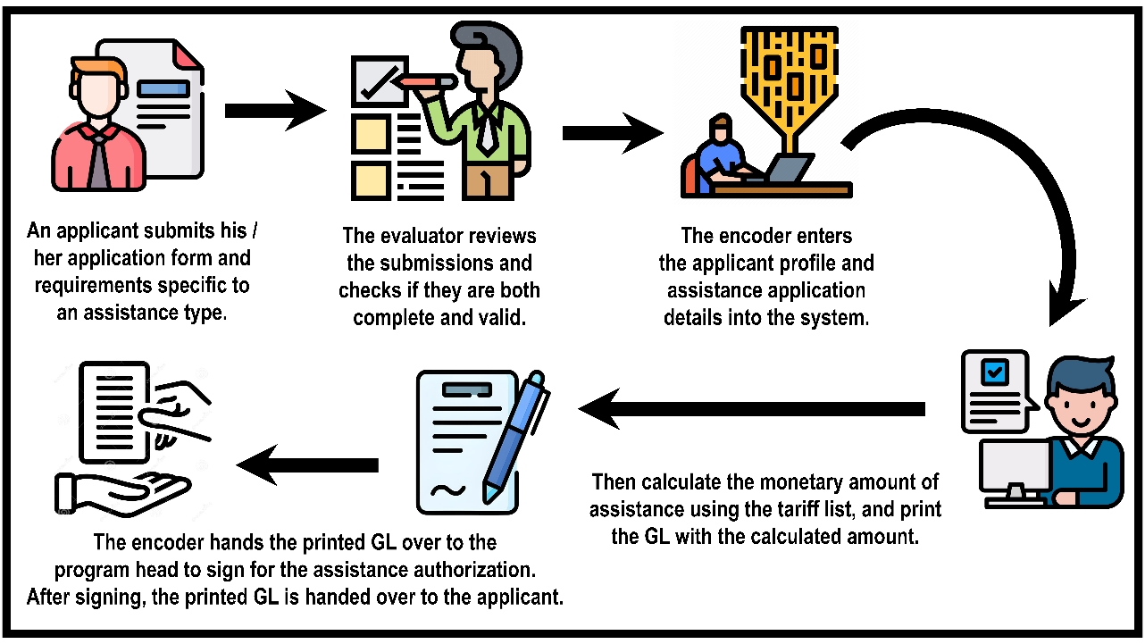

Figure 5 – Organization’s Operational Framework

The AMPING’s operational framework shows the assistance application process workflow of the AMPING office before implementing the system. The applicants visit the program’s office in person to apply for assistance, then they fill out and submit paper-based application forms, along with documents required for every type of assistance they have chosen. An evaluator interviews the applicants, then reviews the forms and documents for completeness and validity as bases to move forward in the process. An encoder enters the applicants’ personal details and chosen assistance types into spreadsheet files on Microsoft Excel, calculates the monetary amount of assistance for every entry using tariff lists, and prints GLs. The program head gets the printed GLs, reviews and signs the GLs to authorize assistance. The signed GLs are given back to the amping staff, who then gives them to the applicants.

Project In-Scope and Out-Scope

The in-scope of this capstone project focuses on developing the medical assistance monitoring and notification system for the Auxiliaries and Medical Program for Individuals and Needy Generals (AMPING).

**In-Scope**

* Profiling of direct (Program Head and Encoders) and indirect users (Applicants, Patients, Sponsor, Affiliate Partners).
* Assignment of the encoder role by the Program Head.
* Monitoring of the budget of the government program in certain time frames.
* Multi-source budget updates performed only by the Program Head.
* Customization of the names and definitions of roles and occupations.
* Customization of the templates of application forms, GLs, and SMS notifications.
* Handling of medical assistance requests and guarantee letters.
* Monitoring of the applicants’ guarantee letters and reapplication dates.
* One-way delivery of SMS notifications (text messages) to applicants.
* Generation and printing of logs and reports for evaluation and feedback.

**Out-Scope**

* Development of the mobile application version of the system.
* Making applicant and patient accounts have access to the system.
* Handling of funeral assistance requests.
* Developing feature to enable applicants to reply back to the system’s SMS.
* Development of new hardware for the system.
* Integration with systems used by the program’s affiliate partners.
* Handling billing process between the program and affiliate partners.
* Integration of telecommunication service provides to the system.

Story Board

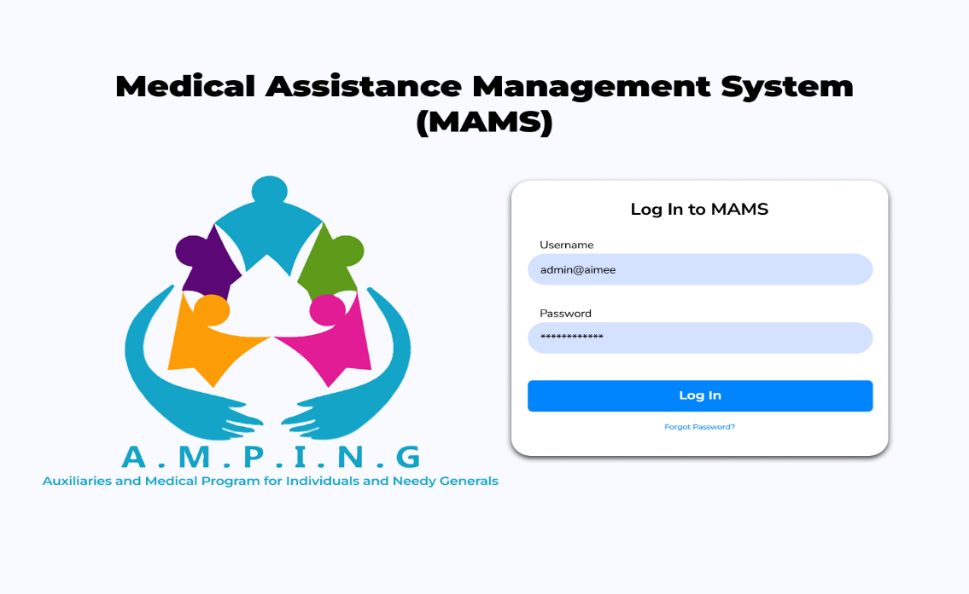

Figure 6 – Story Board

The researchers developed a first prototype or user interface design of   
the AMPING Medical Assistance Monitoring and Notification System using Figma to see how the system would appear and perform after the development. This design will be used as a guideline to the system structure, layout, and features, so that it will be user-friendly and well structured. The prototype indicates the log in page whereby the user can access the system safely by inputting his/her username and password. This also includes the AMPING program’s logo and title to make the system and its purpose clear. Using such a visual design, the researchers could plan and show the system outlook and usability prior to actual coding and development. This process assists in getting areas of improvement and makes sure that the end system will satisfy the needs of the users.

Data Model

In this phase, the researchers developed a data model through an Entity Relationship Diagram. It shows how entities and their attributes are connected, helping organize data, reduce duplication and maintain accuracy. The ERD of the system is shown on the next page.

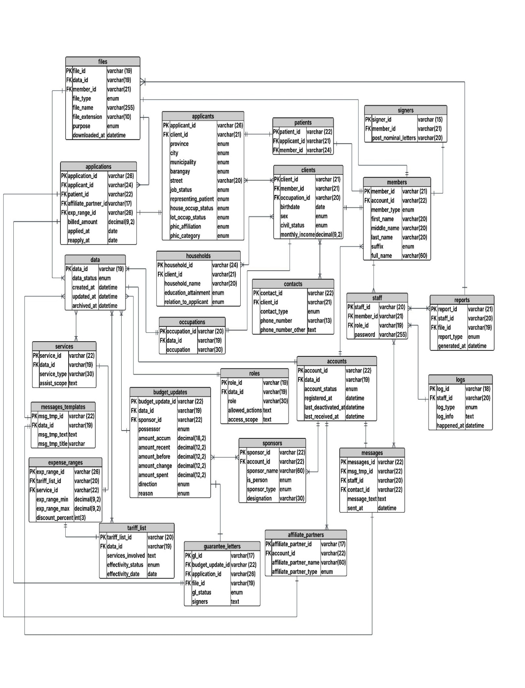Entity Relational Diagram

Figure 7 – Entity Relational Diagram

The Full Database Structure of the AMPING-MAMANS system is shown above in the Entity Relational Diagram, which shows all tables, their fields and the relationship among them. The main working entities are the accounts, members, clients, applicants, applications, patients, guarantee letters, services, budget updates, tariff lists, messages, and reports that are all connected to each other to facilitate well-functioning of the system. Examples include relationships between accounts and members, between members and clients and application with applicants, patients and guarantee letters. Besides these, other supporting entities, including contacts, households, occupations, staff, roles, files, message templates, affiliate partners, sponsors, expense ranges, signers, and logs, offer the relevant information to handle users, roles, communications, tracking, and system general functionality. This database structure, together, will make sure that any records are properly structured, linked, and maintained so that they are easily processed, monitored, and reported on the medical assistance activities of the AMPING program.

Data Dictionary

|  |  |  |  |  |  |
| --- | --- | --- | --- | --- | --- |
| **Table Name** | **Field Name** | **Data Type** | **Constraints** | | **Description** |
| **Account** | account_id | varchar (22) | Primary Key | | Unique identifier for the accounts |
| data_id | varchar (19) | Foreign Key | | Reference to data table |
| account_status | enum |  | | Status of the account (active, inactive, etc.) |
| registered_at | datetime |  | | When the account was registered |
| last_deactivated_at | datetime |  | | When the account was last deactivated |
| last_reactivated_at | datetime |  | | When the account was last reactivated |
| **Partner** | partner_id | varchar (17) | Primary Key | | Unique identifier for the Affiliate Partner |
| account_id | varchar (22) | Foreign Key | | Reference to accounts table |
| affiliate_partner_  name | varchar (60) |  | | Name of the Affiliate Partner |
| affiliate_partner_  type | enum |  | | Type of the affiliate Partner |
| **Contact** | contact_id | varchar (22) | Primary Key | | Unique identifier for the contacts |
| client_id | varchar (21) | Foreign Key | | Reference to clients table |
| contact_type | Enum |  | | Type of contact (phone, email, etc.) |
| phone_number | varchar (13) |  | | Primary phone number |
| phone_number_  other | Text |  | | Additional phone number |
| **Household** | household_id | varchar (24) | Primary Key | | Unique identifier for the Household |
| client_id | varchar (21) | Foreign Key | | Reference to Clients table |
| household_name | varchar (20) |  | | Name of the Household |
| education_  attainment | enum |  | | Education level of household member |
| relation_to_  applicant | enum |  | | Relationship to the primary applicant |
| **Application** | application_id | varchar (26) | Primary Key | | Unique identifier for the Applications |
| applicant_id | varchar (24) | Foreign Key | | Reference to Applicants table |
| Patient_id | varchar (22) | Foreign Key | | Reference to Patient table |
| affiliate_partner_id | varchar (17) | Foreign Key | | Reference to Affiliate Partner table |
| exp_range_id | varchar (26) | Foreign Key | | Reference to Expense Ranges table |
| billed_amount | decimal (9,2) |  | | The total cost of medical services charged by hospital, pharmacies or partner providers. |
| applied_at | datetime |  | | When the application was submitted |
| reapply_at | date |  | | When the applicant can reapply |
| **Patient** | patient_id | varchar (22) | Primary Key | | Unique identifier for the Patients |
| member_id | varchar (21) | Foreign Key | | Reference to Members table |
| applicant_id | varchar (20) | Foreign Key | | Reference to Applicants table |
| **Message**  **Template** | msg_tmp_id | varchar (22) | Primary Key | | Unique identifier for the Message Template |
| data_id | varchar (19) | Foreign Key | | Reference to Data table |
| msg_tmp_text | text |  | | Content of the message Template |
| msg_tmp_title | varchar (30) |  | | Message templates title |
| **Message** | message_id | varchar (22) | Primary Key | | Unique identifier for the Messages |
| msg_tmp_id | varchar (22) | Foreign Key | | Reference to Message Templates table |
| staff_id | varchar (20) | Foreign Key | | Reference to staff table |
| contact_id | varchar (22) | Foreign Key | | Reference to Contacts table |
| message_text | text |  | | Content of the message |
| sent_at | datetime |  | | When the message was delivered |
| **Member** | member_id | varchar (21) | Primary Key | | Unique identifier for the Member |
| account_id | varchar (22) | Foreign Key | | Reference to Accounts table |
| member_type | enum |  | | Type of member |
| first_name | varchar (20) |  | | First name of the member |
| middle_name | varchar (20) |  | | Middle name of the member |
| last_name | varchar (20) |  | | Last name of the member |
| suffix | enum |  | | Name suffix |
| fullname | varchar (60) |  | | Full name of the member |
| **Client** | client_id | varchar (21) | Primary Key | | Unique identifier for the Client |
| member_id | varchar (21) | Foreign Key | | Reference to Members table |
| occupation_id | varchar (20) | Foreign Key | | Reference to Occupations table |
| birthdate | date |  | | Client's date of birth |
| sex | enum |  | | Client's gender |
| civil_status | enum |  | | Client's marital status |
| monthly_income | decimal (9,2) |  | | Client's monthly income |
| **Occupation** | occupation_id | varchar (20) | Primary Key | | Unique identifier for the Occupation |
| data_id | varchar (19) | Foreign Key | | Reference to Data table |
| occupation | varchar (30) |  | | Name of the Occupation |
| **Applicant** | applicant_id | varchar (26) | Primary Key | | Unique identifier for the Applicant |
| client_id | varchar (21) | Foreign Key | | Reference to Clients table |
| province | enum |  | | Applicant's province |
| city | enum |  | | Applicant's city |
| municipality | enum |  | | Applicant's municipality |
| barangay | enum |  | | Applicant's barangay |
| street | varchar (20) |  | | Applicant's street address |
| job_status | enum |  | | Applicant's employment status |
| representing_patients | enum |  | | Whether representing a patient |
| house_occup_status | enum |  | | House occupancy status |
| lot_occup_status | enum |  | | Lot occupancy status |
| phic_affiliation | enum |  | | PHIC affiliation status |
| phic_category | enum |  | | PHIC category |
| **Guarantee**  **Letter** | gl_id | varchar (17) | Primary Key | | Unique identifier for the Guarantee Letter |
| budget_update_id | varchar (22) | Foreign Key | | Reference to Budget Updates table |
| application_id | varchar (26) | Foreign Key | | Reference to Application table |
| file_id | varchar (19) | Foreign Key | | Reference to files table |
| gl_status | enum |  | | Status of the guarantee letter |
| signers | text |  | | People who approved and sign the guarantee letters |
| **Service** | service_id | varchar (22) | Primary Key | | Unique identifier for the Service |
| data_id | varchar (19) | Foreign Key | | Reference to Data table |
| services_type | varchar (30) |  | | Type of the service |
| assist_scope | text |  | | Scope of assistance provided |
| data_id | varchar (19) | Primary Key | | Unique identifier for the Data |
| data_status | enum |  | | Status of the data record |
| created_at | datetime |  | | When the record was created |
| updated_at | datetime |  | | When the record was last updated |
| archived_at | datetime |  | | When the record was archived |
| **Staff** | staff_id | varchar (20) | Primary Key | | Unique identifier for the Staff Member |
| member_id | varchar (21) | Foreign Key | | Reference to Members table |
| role_id | varchar (19) | Foreign Key | | Reference to Roles table |
| password | varchar (255) |  | | Staff member's password |
| **Role** | role_id | varchar (19) | Primary Key | | Unique identifier for the Role |
| data_id | varchar (19) | Foreign Key | | Reference to Data table |
| role | varchar (30) |  | | Name of the role |
| allowed_actions | text |  | | Actions permitted for this role |
| access_scope | text |  | | Scope of access for this role |
| **Log** | log_id | varchar (18) | Primary Key | | Unique identifier for the Log |
| staff_id | varchar (20) | Foreign Key | | Reference to Staffs table |
| log_type | enum |  | | Type of log entry |
| log_info | text |  | | Information about the logged event |
| happened_at | datetime |  | | When the event occurred |
| **Report** | report_id | varchar (21) | Primary Key | | Unique identifier for the Report |
| staff_id | varchar (20) | Foreign Key | | Reference to Staffs table |
| file_id | varchar (19) | Foreign Key | | Reference to Files table |
| report_type | enum |  | | Type of report |
| generated_at | datetime |  | | When the reports generated |
| **File** | file_id | varchar (19) | Primary Key | | Unique identifier for the File |
| data_id | varchar (19) | Foreign Key | | Reference to Data table |
| member_id | varchar (21) | Foreign Key | | Reference to Member table |
| file_type | enum |  | | Type of file |
| filename | varchar (255) |  | | Name of the file |
| file_extension | varchar (10) |  | | File extension |
| purpose | enum |  | | Purpose of the file |
| downloaded_at | datetime |  | | When the file was downloaded |
| **Budget Update** | budget_update_id | varchar (22) | Primary Key | | Unique identifier for the Budget Update |
| data_id | varchar (19) | Foreign Key | | Reference to Data table |
| sponsor_id | varchar (22) | Foreign Key | | Reference to the Sponsor table |
| possessor | enum |  | | Name or title of the budget possessor/holder |
| amount_accum | decimal(18,2) |  | | Total accumulated budget amount |
| amount_recent | decimal(12,2) |  | | Most recent budget amount |
| amount_before | decimal(12,2) |  | | Previous budget amount |
| amount_change | decimal(12,2) |  | | Change in budget amount |
| amount_spent | decimal(12,2) |  | | The budget already used for assistance |
| direction | enum |  | | Direction of change (increase/decrease) |
| reason | enum |  | | Reason for the budget change |
| **Tariff List** | tariff_list_id | varchar (20) | Primary Key | | Unique identifier for the Tariff List |
| data_id | varchar (19) | Foreign Key | | Reference to Data table |
| service_involved | text |  | | Services included in the tariff list |
| effectivity_status | enum |  | | Status of the tariff (active,inactive,pending) |
| effectivity_date | date |  | | Date when the tariff list becomes effective |
| **Expense Range** | exp_range_id | varchar (26) | Primary Key | | Unique identifier for the Expense Range |
| tariff_list_id | varchar (20) | Foreign Key | | Reference to Tariff Lists table |
| service_id | varchar (22) | Foreign Key | | Reference to the Services table |
| exp_range_min | decimal (9,2) |  | | Minimum expense amount covered |
| exp_range_max | decimal (9,2) |  | | Maximum expense amount covered |
| discount_percent | int(3) |  | | Percentage of discount applied to the service. |
| **Sponsor** | sponsor_id | varchar (22) | | Primary Key | Unique identifier for the Expense Range |
| account_id | varchar (22) | | Foreign Key | Reference to Account table |
| sponsor_name | varchar (60) | |  | Name of the sponsor |
| organization_name | enum | |  | Name of the organization |
| sponsor_type | enum | |  | Type of the sponsor |
| designation | varchar | |  | Position, role, and title of the sponsor |
| **Signers** | signers_id | varchar (15) | | Primary Key | Unique identifier for the Signers |
| member_id | varchar (21) | | Foreign Key | Reference to Member Table |
| post_nominal_letters | varchar (20) | |  | Letters after a name showing title |

**Table 1: Data Dictionary**

This data dictionary describes the organization of AMPING Medical Assistance Monitoring and Notification System database. It enumerates all the tables, their fields, data type and the relationship between them. Primary and foreign keys intended to maintain the accuracy and consistency of the data are used to connect the main tables such as Accounts, Members, Clients, Applicants and Staff. The activities of the system are captured in other tables including Applications, Messages, Reports and budget update. All in all, it assists users to appreciate how information is stored, related and handled in the system.

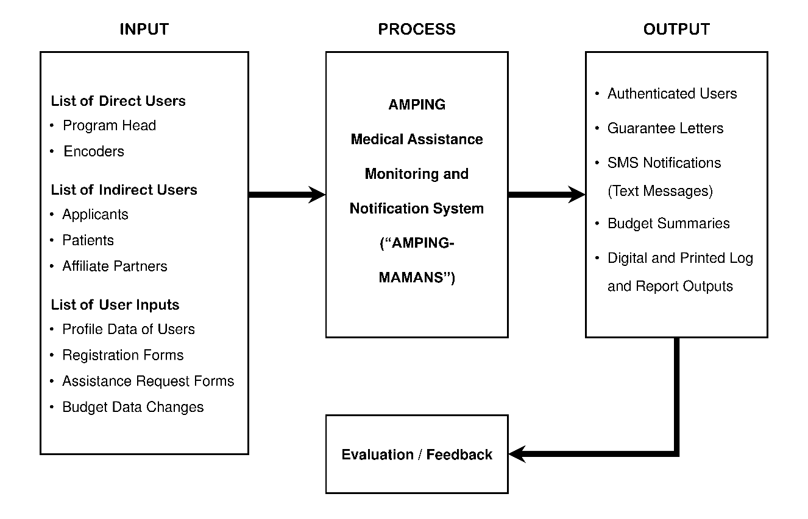Conceptual Framework

Figure 8 – Conceptual Framework

The conceptual framework demonstrates how the system works in terms of input and output process. The direct users will be Program Head and Encoders, operating the system and the indirect ones will be Applicants, Patients, and Affiliate Partners, who will receive the services. The type of information that is entered by users is profile information, registration, requests of assistance and budgets. They are accommodated inside the system to process requests, keep up with fund allocation and give notifications. Secure access by users, generated guarantee letters, SMS alerts, budget summaries, and printed report are some of the system outputs. Last but not the least, evaluation and feedback make a system improve its performance and services continuously.

System Architecture

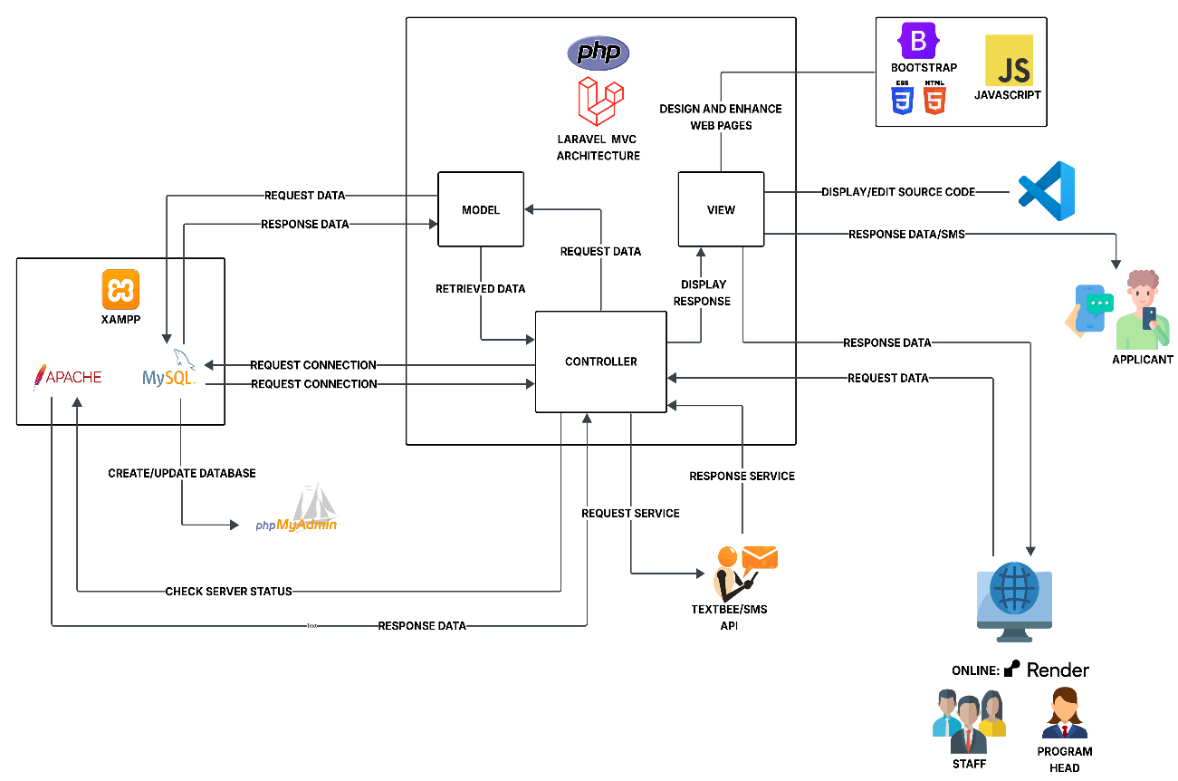

Figure 9 – System Architecture

AMPING Medical Assistance Monitoring and Notification System is an online application that is created to organize and oversee the program of AMPING. It is based on the Laravel MVC (Model-View-Controller), which has a well-structured organization of its elements and data flow. When a member of staff or a program head logs in to the system via the online platform provided via Render, the Controller will first verify the status of the server using Apache in the XAMPP package and will then be linked to the MySQL database to retrieve or update data. The Model receives the data requested and communicates with the database and gives the results to the Controller which sends the processed information to the View to be displayed. The View created and improved with the help of Bootstrap and JavaScript has an extensive interface interaction as well as user-friendliness. Coding and editing of source files is done by visual studio code (VS Code) and phpMyAdmin provides assistance in managing the database. In addition, the system incorporates the Textbee SMS API that will be used to issue automated SMS messages to the applicants to inform them of the status of their applications. This architecture will provide the system with efficient and responsive online communication between the staff, program head, and applicants.

Implementation

This is when the researchers would start the actual programming for the system using Visual Studio Code (VS Code) after making the necessary plans. In VS Code’s command-line interface (CLI) using Composer, they would install packages, libraries, and other dependencies for the system to use alongside programming. With the help of Laravel and Bootstrap, they would be able to write fairly simpler CSS and PHP source codes placed in the intuitive directory of the project’s file system, putting them as parts together in building the computer system, while following the illustrations that the researchers made, also helping them place properly HTML, CSS, and JS codes in frontend-related folders and codes related to PHP and MySQL in backend-related folders. They would also integrate a third-party tool, the SMS API of TextBee, to the system for its SMS feature to work. Other features such as document management, system reporting, RBAC, and security would also be integrated to the system.

Testing

This is when the researchers would start running the system to verify and ensure that it works as intended. They would continuously search for inaccurate parts in source codes and remove them from the codes, and also add things to improve for the codes, until the file system of the computer system is suitable to be deployed in the AMPING Office. This phase would cover having the system to be used by the target users, clients and employees, to handle and manipulate AMPING-related data within the components of the system, while also testing its security feature to ensure that enough security exists in the system.

Data Analysis Plan

The study conducts a rigorous test of the AMPING Medical Assistance Monitoring and Notification System to understand its impact in implementation to the research locale. The main objective is to examine how the system works, and how it is received and generally viewed by the staff members at the AMPING office, as the primary users. By implementing a mixed-methods approach, the quantitative and qualitative can explain the system's strengths and areas for improvement, and make the findings based on real experiences of the users.

* **Objective**: To evaluate the AMPING-MAMANS based on its functionality, usability, reliability, performance, and supportability (FURPS). The study intends to measure how effective it makes the program’s operations simpler and to analyze satisfaction among the AMPING staff members.
* **Data Collection Method**: The data from ten (10) volunteered AMPING staff members and applicants, as the target system users and survey participants, will be collected by the survey questionnaire structured by the researchers based on the system’s attributes. With proper hands-on training for the users to use the system, the evaluation process will be conducted fair and square.
* The survey questionnaire, based on the FURPS model, consists of:
  + **Closed-ended statements**: Rated on a 5-point Likert scale, where 1 and 5 means highest negative and positive responses respectively, to gather quantitative data across the five FURPS categories.
  + **Open-ended section**: “Recommendations / Suggestions” section to collect qualitative data by allowing users to provide comments and critiques about the system for future improvement.
* **Data Description**: The response data set from all ten (10) participants.
  + **Quantitative Data**: Number-based ratings for each of the twenty-five (25) statements for staff members and ten (10) statements for the applicants within the FURPS model. The data here will also be connected to the role, age, and sex of the respondents.
  + **Qualitative Data**: Written responses from the open-ended section of the questionnaire, taking the experiences, opinions, and suggestions of the respondents about the system.
* **Analysis Techniques**: A mixed-methods approach will be used in breaking down collected data into parts to know and understand in full.
  + **Quantitative Analysis**: The researchers will compute the **mean or average score** for each of the questions of each of the following FURPS categories: functionality, usability, reliability, performance, supportability. The data will also be broken down based on role, age, and sex to identify any significant differences in perception between each of the different groups of users.
  + **Qualitative Analysis**: The researchers will perform **thematic analysis** on the written responses of the respondents on the "Recommendations / Suggestions" section. The researchers will read through all responses, identifying similar ideas, and grouping them into different themes that help them to understand the specific reasons of the results from the quantitative ratings and capture meaningful ideas for improvement according to the users.
* **Data Interpretation**: The survey results will be interpreted to come up with meaningful conclusions about the system's quality.
  + The calculated mean scores for the quantitative data will be interpreted using the Likert scale’s definitions.
  + The themes identified from the qualitative data will provide context and depth to the numerical scores, explaining why users rated certain aspects highly or identified areas for improvement.
* **Tools and Software**: Data analysis will be conducted with the following:
  + **Microsoft Excel**: For the quantitative analysis, such as data entry, mean score calculations, and visualized table and chart creation.
  + **Microsoft Word**: For the qualitative analysis, such as transcribing, organizing, and interpreting the textual feedback to identify themes.
* **Limitations**: This data analysis has a few potential limitations.
  + **Sample Size**: The study involves 10 respondents. While this may represent the whole population of the AMPING office staff, they still may limit the ability to generalize the findings.
  + **Response Bias**: Since the selected respondents would have been trained by the research team and aware that they are part of this study, social-desirability bias is impossible to avoid, where they may want to provide positive feedback that the researchers want.
* **Reporting Results**: The findings of the data analysis will be presented in the Chapter V of the capstone project research document.
  + Quantitative results will be provided in tables to define the mean scores and interpretations for every FURPS category. Mean scores based on role, age, and sex will also be presented in tables.
  + Qualitative results will be provided as a summary of main themes from feedback from certain unnamed participants where applicable.

Implementation Plan

|  |  |  |  |
| --- | --- | --- | --- |
| **STRATEGY** | **ACTIVITIES** | **PERSONS INVOLVED** | **DURATION** |
| **System Evaluation** | | | |
| System Evaluation Tool Creation | Making System Evaluation Tool | Researchers | 5 days |
| System Evaluation Tool Approval | Obtain Approval for System Evaluation Tool | Researchers & Adviser | 1 day |
| Making Letter to Conduct System Evaluation | Draft letter to conduct system evaluation for the AMPING office | Researchers | 4 days |
| Letter to Conduct System Evaluation Approval | Obtain Approval for Letter to Conduct System Evaluation | Researchers & Adviser | 1 day |
| Submission of Letter to Conduct System Evaluation | Submit the letter to the AMPING office | Researchers & AMPING Program Head | 1 day |
| Approved Letter to Conduct System Evaluation | Receive approval for letter from the AMPING | Researchers | 1 day |
| **System Installation** | | | |
| Setup The System | Install the system and configure database & SMS API | Researchers | 1 day |
| **System Testing** | | | |
| Testing The System | Run the system with sample data to check functions and fix minor issues | Researchers | 1 day |
| **System Deployment** | | | |
| Local Deployment | Deploy the system in AMPING office and orient the users (AMPING Staffs & Program Head) | Researchers, Staff Members & AMPING Program Head | 1 day |
| **Conduct System Evaluation** | | | |
| Conducting System Evaluation | Evaluate the system in the AMPING office, using survey forms and staff feedbacks. | Researchers, Staff Members & AMPING Program Head | 1 day |

**Table 2: Implementation Plan**

This implementation plan indicates how to follow the step-by-step implementation of the system. It involves development and acceptance of evaluation tools and letters, configuration and testing of the system, implementation of the system in the AMPING office, and lastly the system evaluation. The activities include names of those involved in each one- primarily the researchers, adviser, the AMPING staff, and the head of the program and the duration of the step taken to be completed. In general, the plan will guarantee that the system is well prepared, tested, and assessed before its complete use.

Deployment

This is when the researchers would install, test and implement the system in the AMPING Office. They would set up and connect XAMPP to every computer in the office, configure Apache virtual host for the system, set a strong password for every AMPING employee user, and enable necessary networking ports. After these, the researchers and employee users would move existing, recorded data pieces and/or create backup of them to the system. Then, the researchers would teach and train all types of the system users, such as in RBAC, SMS, document management, and system reporting. Then, the researchers and the administrator of the system, program head, would configure and secure an SMS API key.

Maintenance

This is when the researchers would perform daily system backups and updates, based on user feedback, to deal with downtimes and cyberattacks, as well as calculation changes in times that tariff list information would become different in the future from the current information, for every medical assistance type. If the system operation would be successful, the researchers might add the funeral assistance types and clients’ system access in the future.

CHAPTER V

**RESULTS AND DISCUSSION**

The implementation of the system in the research locale attempted to automate processes and computerize the previously paper-based and spreadsheet-filled data. This initiative aimed at solving problems which included poor data retrieval, overspending of budget, and lack of communication with the applicants. The researchers have extensively evaluated the system on a mixed-methods basis to determine the system effectiveness and its acceptance by users. In this research, the survey questionnaire was developed considering the Functionality, Usability, Reliability, Performance and Supportability or FURPS model with a 5-point Likert scale quantitative data and qualitative feedback. The sample used in collecting the data was the 10 participants of AMPING Staff including their Program Head that volunteered to participate in the survey as the main users of the system. The mean score of each category was calculated to measure the usefulness of the system for the users.

**Table 3**

**FUNCTIONALITY RESULT**

|  |  |  |
| --- | --- | --- |
| **Statements** | **Mean** | **Description** |
| 1. The Guarantee Letter generator created accurate GLs every time. | 4.3 | *Agree* |
| 1. The SMS notification feature sends reminders and updates correctly. | 3.9 | *Agree* |
| 1. The Budget Monitoring tool shows the remaining funds clearly. | 4.2 | *Agree* |
| 1. The Application recording feature keeps applicant and patient details complete. | 4.1 | *Agree* |
| 1. The system automatically calculates the correct amount of medical assistance based on the tariff list. | 4.2 | *Agree* |
| **Total Mean** | 4.14 | *Agree* |

Legend: 4.50 – 5.00 Strongly Agree

3.50 – 4.49 Agree

2.50 – 3.49 Neutral

1.50 – 2.49 Disagree

1.00 – 1.49 Strongly Disagree

Table 3 shows that the system’s functionality obtained positive feedback from users. Most respondents agreed that the system performs its tasks correctly and efficiently. Features like Guarantee Letter generator, SMS notification, and Budget Monitoring tool worked as expected. Users also found that the system records details completely and calculates assistance amounts accurately. With a total mean of 4.14, the results shows that the system is functional and dependable for its users.

**Table 4**

**USABILITY RESULT**

|  |  |  |
| --- | --- | --- |
| **Statements** | **Mean** | **Description** |
| 1. The menu and dashboard are easy to navigate. | 4.5 | *Strongly Agree* |
| 1. The labels, buttons, and forms are clear and understandable. | 4.3 | *Agree* |
| 1. Searching for applicant profiles and applicant entries is simple. | 4.2 | *Agree* |
| 1. Error messages clearly explain clearly what needs to be fixed. | 4.1 | *Agree* |
| 1. The overall design of the web pages looks neat and consistent. | 4.4 | *Agree* |
| **Total Mean** | 4.3 | *Agree* |

Legend: 4.50 – 5.00 Strongly Agree

3.50 – 4.49 Agree

2.50 – 3.49 Neutral

1.50 – 2.49 Disagree

1.00 – 1.49 Strongly Disagree

Based on the results, users found the system very easy to use and understand. Most agreed that the menus, buttons and forms are simple to navigate and clearly labeled. Searching for applicants and fixing errors were also easy to do. The system’s web design was described as neat and consistent by users. With a total mean of 4.3, the system is considered user-friendly and well-organized.

**Table 5**

**RELIABILITY RESULT**

|  |  |  |
| --- | --- | --- |
| **Statements** | **Mean** | **Description** |
| 1. The system rarely experiences crashes or stops working. | 4.1 | *Agree* |
| 1. Once I save applicant or budget data, it stays correct and accurate. | 4.2 | *Agree* |
| 1. The system recovers quickly after errors or interruptions. | 3.9 | *Agree* |
| 1. The calculation of medical assistance amounts is always correct. | 4.1 | *Agree* |
| 1. SMS notifications are always delivered to the correct applicant’s phone number. | 4 | *Agree* |
| **Total Mean** | 4.06 | *Agree* |

Legend: 4.50 – 5.00 Strongly Agree

3.50 – 4.49 Agree

2.50 – 3.49 Neutral

1.50 – 2.49 Disagree

1.00 – 1.49 Strongly Disagree

The results indicate that the system is reliable and performs tasks accurately. Users agreed that it rarely crashes and keeps saved data correct and safe. It can recover quickly from small errors or interruptions. The system also delivers correct calculations and messages to the right people. With a total mean of 4.06, the system is dependable and trustworthy for regular use.

**Table 6**

**PERFORMANCE RESULT**

|  |  |  |
| --- | --- | --- |
| **Statements** | **Mean** | **Description** |
| 1. The web pages load quickly when I navigate through the system. | 4.1 | *Agree* |
| 1. Reports and guarantee letters are generated right away without delay. | 3.9 | *Agree* |
| 1. The system still works smoothly even when many staff are using it at the same time. | 3.9 | *Agree* |
| 1. The system quickly saves and updates applications for daily use. | 3.9 | *Agree* |
| 1. The system updates budget records immediately after every transaction. | 4 | *Agree* |
| **Total Mean** | 3.96 | *Agree* |

Legend: 4.50 – 5.00 Strongly Agree

3.50 – 4.49 Agree

2.50 – 3.49 Neutral

1.50 – 2.49 Disagree

1.00 – 1.49 Strongly Disagree

According to the findings, the system performs well in terms of speed and response time. Users agreed that page’s load fast and reports are generated without long delays. The system still works smoothly even when many people use it at once. It also updates applications and budget records quickly. With total mean of 3.96, the system has good performance and runs effectively.

**Table 7**

**SUPPORTABILITY RESULT**

|  |  |  |
| --- | --- | --- |
| **Statements** | **Mean** | **Description** |
| 1. The system can easily add or update user roles and permissions. | 4.2 | *Agree* |
| 1. The system can add or update affiliate partners when needed. | 4 | *Agree* |
| 1. The system keeps a clear record of previous applications for reference. | 3.8 | *Agree* |
| 1. The system allows updating tariff lists (medical service prices) when there are changes. | 4.2 | *Agree* |
| 1. The system enables adding new sponsors or fund sources when needed. | 4.2 | *Agree* |
| **Total Mean** | 4.08 | *Agree* |

Legend: 4.50 – 5.00 Strongly Agree

3.50 – 4.49 Agree

2.50 – 3.49 Neutral

1.50 – 2.49 Disagree

1.00 – 1.49 Strongly Disagree

The findings shown in table 7 shows that the system can easily adjust to changes and updates when needed. Users mentioned that adding or editing user roles, partners, sponsor can be done without difficulty. This makes it easier to manage the system when there are new updates or changes. They also liked that the system keeps clear and organized records of past applications. It is also helpful that medical service prices can be updated quickly when needed. These features make the system more flexible and easier to use. Users also mentioned that it helps reduce the need for extra technical help. With a total mean of 4.08, the system is seen as adaptable and ready for future improvements.

CHAPTER VI

**SUMMARY, CONCLUSIONS, AND RECOMMENDATIONS**

**Summary of Findings**

The evaluation results of the system, revealed that the AMPING Medical Assistance Monitoring and Notification System was positively received by its users. In terms of **functionality**, with a mean score of **4.14**, users agreed that the system performs its intended functions properly such as generating reports, managing data, and processing transactions precisely. For **usability**, which obtained the highest mean of **4.3**, users found the system is easy to use and understand. The menus, buttons, and forms were described as clear, simple to navigate, and user-friendly, which helped users accomplish their tasks successfully. Under **reliability**, with a mean score of **4.06,** users confirmed that the system is stable, rarely experience errors, and maintains the accuracy and security of stored data. The **performance** aspect, with a mean of **3.96**, indicated that the system runs smoothly, loads pages quickly, and functions well even when multiple users access it all at once. Lastly, the **supportability** result, with a mean of **4.08**, showed that the system is flexible and can be easily updated or modified when needed.

In addition, several respondents commented that the system is a helpful tool for their office operations, as it makes monitoring and processing medical assistance faster and more organized. However, some users suggested improving how applicant applications are processed consecutively for better tracking and fairness in managing request. Overall, the total mean of **4.11** indicates that users agreed the system is efficient, functional and dependable in performing its purpose of improving the monitoring and notification process for medical assistance.

**Conclusions**

According to the results of the survey, the system works well and is a helpful tool for managing medical assistance. It is easy to use, so users can do their work faster and with less effort. It helps users save time in generating guarantee letters, managing data, and performing its tasks exactly. It is easy to use, as users can quickly navigate through menus, buttons, and forms without confusion. The system is also reliable since it rarely crashes and keeps saved information correct and secure. It performs smoothly even when several users access it at the same time, showing good system performance. Moreover, it can be easily updated or improved when needed, making it flexible and ready for future changes. Some users also mentioned that the system is a very helpful tool for their office, though they suggested improving how applicant applications are processed in order, following a first come, first serve setup for fairness and better organization. Overall, the respondents shared that the system really helped make their work easier and faster. They said it saves them time and helps keep their tasks more organized and precise. Many of them found it simple to use and liked how it made managing applications and data less stressful. They also appreciated that system runs smoothly and rarely encounters problems. Most of them believe that with a few more updates and improvements, the system can become an even more helpful and reliable tool for their everyday work in providing medical assistance.

**Recommendations**

In accordance with the feedback and suggestions gathered from the respondents during the system evaluation, the following recommendations are proposed to further improve the AMPING Medical Assistance Monitoring and Notification System.

1. **Add applicant numbering** to assign a unique application number to every applicant. This will help ensure that all applications are processed in order, following an ordered process approach.
2. **Use color marks in the list of applicants** to easily identify the status of each application. For example, using the color **red** to mark cancelled applications can help users quickly recognize and manage records more efficiently.

REFERENCES

Anthopoulos, L., Reddick, C. G., Giannakidou, I., & Mavridis, N. (2016). Why e-government projects fail? An analysis of the Healthcare.gov website. *Government Information Quarterly*, *33*(1), 161–173. https://doi.org/10.1016/j.giq.2015.07.003

*Barangay profiling system capstone project*. (2022). Capstone Guide. Retrieved March 27, 2025, from https://capstoneguide.com/barangay-profiling-system-capstone-project/

Castro, F. DocTrack: A dynamic document tracking system for the University of Northern Philippines (2022). *Journal of Innovative Technology Convergence*, *4*(2), 23–34. https://doi.org/10.69478/jitc2022v4n2a03

Ejdys, J., Ginevicius, R., Rozsa, Z., & Janoskova, K. (2019). The role of perceived risk and security level in building trust in e-government solutions. *E+M Ekonomie a Management*, *22*(3), 220–235. https://doi.org/10.15240/tul/001/2019-3-014

Grepon, B. G. S. (2021). *Designing and implementing e-justice systems: An information systems approach to Regional Trial Court case docket management in Northern Mindanao, Philippines*. https://doi.org/10.5281/zenodo.4459814

Kiram, D. A. K., Kiram, M. M., Hadjibun, J.-A. A., & Taraji, M. (2025). Data governance and privacy in Sulu, Philippines: Building trust and ensuring accountability in digital public service delivery. *Open Access Indonesia Journal of Social Sciences*, *8*(1), 1952–1966. https://doi.org/10.37275/oaijss.v8i1.283

LGU GenSan: TATAK Heneral. (2024, December 6). LOOK | From January to November 2024, a total of 36,590 beneficiaries have received assistance through the AMPING Office [Image attached] [Status update]. Facebook. https://www.facebook.com/LGUGensanTATAKHENERAL/posts/pfbid084A4hM4HzjunnURbDEj7SkRnMyd93Tqsewri5pV4p6sk7xPegu7hPhrKLrkbEKBNl

Lingaya, S. R. (2019). Towards a bespoke document tracking System for Philippine higher educational institutions. *International Journal of Recent Technology and Engineering (IJRTE)*, *8*(2), 1568–1573. https://doi.org/10.35940/ijrte.b2255.078219

Moreno, F., & Barrios, N. A. (2024). *Evaluating the efficacy of e-government initiatives in addressing local governance challenges: A case study of Zamboanga City, Philippines*. Elsevier BV. https://doi.org/10.2139/ssrn.5057005

Moreno, F., & Delos Reyes-Urmanita, M. J. (2024). *An analytical examination of the preparedness and challenges in the implementation of e-Governance for the optimization of public service delivery in Zamboanga City, Philippines*. Elsevier BV. https://doi.org/10.2139/ssrn.5056998

Moussa, M. (2016). Internet, intranets and extranets in organizations: An integrative literature review. *SIU Journal of management*, 6(1), 1-39.

Munyoka, W., & Maharaj, M. S. (2019). Privacy, security, trust, risk and optimism bias in e-government use: The case of two southern African development community countries. *SA Journal of Information Management*, *21*(1). https://doi.org/10.4102/sajim.v21i1.983

Pabatang-Hussien, E. (2023). Service delivery through e-governance: The case of highly urbanized cities in Northern Mindanao, Philippines. *E3S Web of Conferences*, *440*, 01012. https://doi.org/10.1051/e3sconf/202344001012

Palma, J. P., Avila, L. (2023). E-Governance: A critical review of e-government systems, features, and frameworks for success. *International Journal of Computing Sciences Research*, *7*, 2004–2017. https://doi.org/10.25147/ijcsr.2017.001.1.138

*Patient scheduling and program management system barangay health center*. (2022). Capstone Guide. Retrieved March 27, 2025, from https://capstoneguide.com/patient-scheduling-and-program-management-system-barangay-health-center/

Rellon, S. J., Diolata, A. J., & Sobejana, N. (2020). Web-based document tracking system using barcode technology with SMS notification. *SSRN Electronic Journal*. https://doi.org/10.2139/ssrn.3780539

Rodriguez III, B., Verallo, C. J. A., Aquiatan, V. T., Agpad, S. B., De Loyola, R. C., & Bibangco, E. J. P. (2024). eDALAYON: A document management and monitoring system for the Department of the Interior and Local Government, Philippines. *Philippine Journal of Science, Engineering, and Technology*, *1*(1), 34–41. https://doi.org/10.63179/pjset.v1i1.57

Shaikh, A. Z., Shah, U. L., & Wijekuruppu, C. (2016, June). Public service delivery and e-governance: The case of Pakistan. *International Journal for Infonomics*, *9*(2). https://doi.org/10.20533/iji.1742.4712.2016.0141

APPENDICES

APPENDIX A

**RELEVANT SOURCE CODES**

**File name: dashboard.blade.php**@extends('layouts.personal-pages')

@section('title', 'Dashboard')

@push('styles')

<link href="{{ asset('css/layouts/dashboard.css') }}" rel="stylesheet">

@endpush

@push('scripts')

<script src="{{ asset('js/layouts/dashboard.js') }}"></script>

@endpush

@section('breadcrumbs')

<a href="{{ route('dashboard') }}" class="text-decoration-none text-reset">Dashboard</a>

@endsection

@section('content')

@php

use Illuminate\Support\Facades\DB;

use Illuminate\Support\Carbon;

$currentYear = Carbon::now()->year;

$startOfYear = Carbon::create($currentYear, 1, 1, 0, 0, 0);

$endOfYear = Carbon::create($currentYear, 12, 31, 23, 59, 59);

$startOfToday = Carbon::now()->startOfDay();

$endOfToday = Carbon::now()->endOfDay();

$glYearCount = DB::table('guarantee_letters')->where('gl_status', 'Approved')->count();

$glTodayCount = DB::table('guarantee_letters')->where('gl_status', 'Approved')->count();

$pendingCount = DB::table('applications')->leftJoin('guarantee_letters', 'applications.application_id', '=', 'guarantee_letters.application_id')->whereNull('guarantee_letters.gl_id')->count();

@endphp

<div class="datetime-section">

<div class="date-container">

<div class="datetime" id="live-clock"></div>

</div>

@include('components.utility.date')

</div>

<div class="dashboard-grid mb-4">

<div class="budget-section">

<div class="dashboard-card">

<a class="text-decoration-none text-reset" onclick="window.openAllocateBudgetModal()">

<h6 class="card-title">Allocated Budget:</h6>

<div class="amount" id="allocated-budget-amount">Loading...</div>

</a>

</div>

<div class="dashboard-card">

<a class="text-decoration-none text-reset" href="{{ route('dashboard') }}">

<h6 class="card-title">Budget Amount Used:</h6>

<div class="amount" id="budget-used-amount">Loading...</div>

</a>

</div>

<div class="dashboard-card">

<a class="text-decoration-none text-reset" href="{{ route('dashboard') }}">

<h6 class="card-title">Remaining Budget:</h6>

<div class="amount" id="remaining-budget-amount">Loading...</div>

</a>

</div>

<div class="dashboard-card">

<a class="text-decoration-none text-reset" onclick="window.openSupplementaryBudgetModal()">

<h6 class="card-title">Supplementary Budget Used:</h6>

<div class="amount" id="supplementary-budget-status">Loading...</div>

</a>

</div>

<div class="dashboard-card">

<h6 class="card-title">Approved Guarantee Letters:</h6>

<div class="d-grid my-2" style="grid-template-columns: repeat(2, 1fr); grid-template-rows: repeat(2, auto); gap: 8px;">

<div>

<div class="card-subtitle"><b>Today:</b></div>

<div id="card-subamount-today" class="card-subamount">{{ $glTodayCount }}</div>

</div>

<div>

<div class="card-subtitle"><b>Pending:</b></div>

<div id="card-subamount-pending" class="card-subamount">{{ $pendingCount }}</div>

</div>

<div>

<div class="card-subtitle"><b>In {{ $currentYear }}:</b></div>

<div id="card-subamount-year" class="card-subamount">{{ $glYearCount }}</div>

</div>

</div>

<div class="show-more" style="margin-bottom: -12px;">

<a class="show-more-text" href="{{ route('applications.list') }}">View List</a>

</div>

</div>

<div class="trinity-card d-flex flex-column justify-content-between">

<a class="dashboard-card text-decoration-none d-flex justify-content-between" id="trinityBtns" href="">

<div class="card-special d-flex align-items-center">

<i class="fas fa-user-plus" style="width: 32px; aspect-ratio: 1 / 1;"></i>

<h6 class="trinity-text">Register Applicant<br>(Multi-Step Form)</h6>

</div>

</a>

<a class="dashboard-card text-decoration-none d-flex justify-content-between" id="trinityBtns" href="{{ route('request-service-assistance') }}">

<div class="card-special d-flex align-items-center">

<i class="fas fa-plus-circle"></i>

<h6 class="trinity-text">Request Service Assistance</h6>

</div>

</a>

<a class="dashboard-card text-decoration-none d-flex justify-content-between" id="trinityBtns" href="{{ route('message-templates.index') }}">

<div class="card-special d-flex align-items-center">

<i class="fas fa-comment-alt"></i>

<h6 class="trinity-text">SMS Templates</h6>

</div>

</a>

</div>

</div>

<div class="card-section">

<a class="action-card" href="{{ route('guarantee-letter') }}">

<i class="mt-2 fas fa-file-alt"></i>

<h6>Guarantee Letter</h6>

</a>

<a class="action-card" href="">

<i class="mt-2 fas fa-user-times"></i>

<h6>Deactivated Users</h6>

</a>

<a class="action-card" href="{{ route('tariff-lists') }}">

<i class="mt-2 fas fa-list-alt"></i>

<h6 class="mb-2">Tariff Lists</h6>

</a>

<a class="action-card" href="">

<i class="mt-2 fas fa-archive"></i>

<h6 class="mb-2">Archives</h6>

</a>

<a class="action-card" href="">

<i class="mt-2 fas fa-file-alt"></i>

<h6 class="mb-2">Logs</h6>

</a>

<a class="action-card" href="">

<i class="mt-2 fas fa-chart-line"></i>

<h6 class="mb-2">Reports</h6>

</a>

</div>

<div class="service-table">

<table>

<thead>

<tr>

<th class="service-header">SERVICE TYPE</th>

<th class="tariff-header">TARIFF LIST VERSION USED</th>

</tr>

</thead>

<tbody>

@foreach($serviceTariffMapping as $serviceType => $tariffId)

<tr>

<td class="fw-semibold">{{ $serviceType }}</td>

<td class="fw-semibold">{{ $tariffId }}</td>

</tr>

@endforeach

</tbody>

</table>

<div class="show-more">

<a class="show-more-text" href="{{ route('tariff-lists') }}">Show More...</a>

</div>

</div>

</div>

@endsection

@section('footer')

@include('components.layouts.footer.profile-buttons-1')

@endsection

**File name: client-registration.blade.php**<div>

<form wire:submit="save" class="profile-section" id="profileSection">

<div class="profile-container">

<div class="row gx-3 gy-3 mb-3">

<legend class="form-legend">

<i class="fas fa-user fa-fw"></i><span class="header-title">APPLICANT'S NAME</span>

</legend>

<div class="form-group col-md-3">

<label class="form-label fw-bold">First Name <span class="required-asterisk">*</span></label>

<input type="text" wire:model.live="first_name" class="form-control" id="applicantFirstNameInput" placeholder="Example: Juan">

@error('first_name') <span class="text-danger mt-3">{{ $message }}</span> @enderror

</div>

<div class="form-group col-md-3">

<label class="form-label fw-bold">Middle Name</label>

<input type="text" wire:model.live="middle_name" class="form-control" id="applicantMiddleNameInput" placeholder="Example: Pablo">

@error('middle_name') <span class="text-danger mt-3">{{ $message }}</span> @enderror

</div>

<div class="form-group col-md-3">

<label class="form-label fw-bold">Last Name <span class="required-asterisk">*</span></label>

<input type="text" wire:model.live="last_name" class="form-control" id="applicantLastNameInput" placeholder="Example: Dela Cruz">

@error('last_name') <span class="text-danger mt-3">{{ $message }}</span> @enderror

</div>

<div class="form-group col-md-3">

<label class="form-label fw-bold">Suffix</label>

<div class="dropdown">

<button class="btn dropdown-toggle w-100" type="button" data-bs-toggle="dropdown" id="applicantSuffixDropdownBtn">

{{ $suffix ?: '— Select —' }}

</button>

<ul class="dropdown-menu w-100">

<li><a class="dropdown-item @if($suffix == '') active @endif" href="#" wire:click.prevent="setSuffix('')">— Select —</a></li>

<li><a class="dropdown-item @if($suffix == 'Sr.') active @endif" href="#" wire:click.prevent="setSuffix('Sr.')">Sr.</a></li>

<li><a class="dropdown-item @if($suffix == 'Jr.') active @endif" href="#" wire:click.prevent="setSuffix('Jr.')">Jr.</a></li>

<li><a class="dropdown-item @if($suffix == 'II') active @endif" href="#" wire:click.prevent="setSuffix('II')">II</a></li>

<li><a class="dropdown-item @if($suffix == 'III') active @endif" href="#" wire:click.prevent="setSuffix('III')">III</a></li>

<li><a class="dropdown-item @if($suffix == 'IV') active @endif" href="#" wire:click.prevent="setSuffix('IV')">IV</a></li>

<li><a class="dropdown-item @if($suffix == 'V') active @endif" href="#" wire:click.prevent="setSuffix('V')">V</a></li>

</ul>

</div>

@error('suffix') <span class="text-danger mt-3">{{ $message }}</span> @enderror

</div>

</div>

</div>

<div class="profile-container">

<div class="row gx-3 gy-3 mb-3">

<legend class="form-legend">

<i class="fa fa-info-circle fa-fw"></i><span class="header-title">PERSONAL INFORMATION</span>

</legend>

<div class="form-group col-md-3">

<label class="form-label fw-bold">Sex <span class="required-asterisk">*</span></label>

<div class="dropdown">

<button class="btn dropdown-toggle w-100" type="button" data-bs-toggle="dropdown" id="applicantSexDropdownBtn">

{{ $sex ?: '— Select —' }}

</button>

<ul class="dropdown-menu w-100">

<li><a class="dropdown-item @if($sex == '') active @endif" href="#" wire:click.prevent="setSex('')">— Select —</a></li>

<li><a class="dropdown-item @if($sex == 'Male') active @endif" href="#" wire:click.prevent="setSex('Male')">Male</a></li>

<li><a class="dropdown-item @if($sex == 'Female') active @endif" href="#" wire:click.prevent="setSex('Female')">Female</a></li>

</ul>

</div>

@error('sex') <span class="text-danger mt-3">{{ $message }}</span> @enderror

</div>

<div class="form-group col-md-3">

<label class="form-label fw-bold">Birthdate <span class="required-asterisk">*</span></label>

<input type="date" wire:model.live="birth_date" class="form-control" id="applicantBirthdateInput">

@error('birth_date') <span class="text-danger mt-3">{{ $message }}</span> @enderror

</div>

<div class="form-group col-md-3">

<label class="form-label fw-bold">Phone Number <span class="required-asterisk">*</span></label>

<input type="text" wire:model.live="phone_number" class="form-control" id="applicantPhoneNumberInput" placeholder="Format: &quot;09...&quot; or &quot;+639...&quot;" maxlength="15" inputmode="tel">

@error('phone_number') <span class="text-danger mt-3">{{ $message }}</span> @enderror

</div>

<div class="form-group col-md-3">

<label class="form-label fw-bold">Civil Status <span class="required-asterisk">*</span></label>

<div class="dropdown">

<button class="btn dropdown-toggle w-100" type="button" data-bs-toggle="dropdown" id="applicantCivilStatusDropdownBtn">

{{ $civil_status ?: '— Select —' }}

</button>

<ul class="dropdown-menu w-100">

<li><a class="dropdown-item @if($civil_status == '') active @endif" href="#" wire:click.prevent="setCivilStatus('')">— Select —</a></li>

<li><a class="dropdown-item @if($civil_status == 'Single') active @endif" href="#" wire:click.prevent="setCivilStatus('Single')">Single</a></li>

<li><a class="dropdown-item @if($civil_status == 'Married') active @endif" href="#" wire:click.prevent="setCivilStatus('Married')">Married</a></li>

<li><a class="dropdown-item @if($civil_status == 'Separated') active @endif" href="#" wire:click.prevent="setCivilStatus('Separated')">Separated</a></li>

<li><a class="dropdown-item @if($civil_status == 'Widowed') active @endif" href="#" wire:click.prevent="setCivilStatus('Widowed')">Widowed</a></li>

</ul>

</div>

@error('civil_status') <span class="text-danger mt-3">{{ $message }}</span> @enderror

</div>

</div>

</div>

<div class="profile-container">

<div class="row gx-3 gy-3 mb-3">

<legend class="form-legend">

<i class="fa fa-home fa-fw"></i><span class="header-title">HOME ADDRESS</span>

</legend>

<div class="form-group col-md-2">

<label class="form-label">House # <span class="fw-normal">(if applicable)</span></label>

<input type="text" wire:model.live="house_number" class="form-control" id="applicantHouseNumberInput" placeholder="Either room or lot #">

</div>

<div class="form-group col-md-2">

<label class="form-label">Block # <span class="fw-normal">(if applicable)</span></label>

<input type="text" wire:model.live="block_number" class="form-control" id="applicantBlockNumberInput" placeholder="Ex: Block 1">

</div>

<div class="form-group col-md-2">

<label class="form-label">Phase <span class="fw-normal">(if applicable)</span></label>

<input type="text" wire:model.live="phase" class="form-control" id="applicantPhaseInput" placeholder="Ex: Phase 1-A">

</div>

<div class="form-group col-md-2">

<label class="form-label">Street <span class="fw-normal">(if applicable)</span></label>

<input type="text" wire:model.live="street" class="form-control" id="applicantStreetInput" placeholder="Ex: Matalam St.">

</div>

<div class="form-group col-md-2">

<label class="form-label">Sitio <span class="fw-normal">(if applicable)</span></label>

<input type="text" wire:model.live="sitio" class="form-control" id="applicantSitioInput" placeholder="Ex: Sitio Corazon">

</div>

<div class="form-group col-md-2">

<label class="form-label">Purok <span class="fw-normal">(if applicable)</span></label>

<input type="text" wire:model.live="purok" class="form-control" id="applicantPurokInput" placeholder="Ex: Purok Maunlad">

</div>

<div class="form-group col-md-3">

<label class="form-label">Subdivision <span class="fw-normal">(if applicable)</span></label>

<input type="text" wire:model.live="subdivision" class="form-control" id="applicantSubdivisionInput" placeholder="Ex: Doña Soledad">

</div>

<div class="form-group col-md-3">

<label class="form-label">Barangay <span class="fw-normal">(if applicable)</span></label>

<div class="dropdown">

<button class="btn dropdown-toggle w-100" type="button" data-bs-toggle="dropdown" id="applicantBarangayDropdownBtn">

{{ $barangay ?: '— Select —' }}

</button>

<ul class="dropdown-menu w-100">

<li><a class="dropdown-item @if($barangay == '') active @endif" href="#" wire:click.prevent="setBarangay('')">— Select —</a></li>

@foreach(['Apopong','Baluan','Batomelong','Buayan','Bula','Calumpang','City Heights','Conel','Dadiangas East','Dadiangas North','Dadiangas South','Dadiangas West','Fatima','Katangawan','Labangal','Lagao','Ligaya','Mabuhay','Olympog','San Isidro','San Jose','Siguel','Sinawal','Tambler','Tinagacan','Upper Labay'] as $b)

<li><a class="dropdown-item @if($barangay == $b) active @endif" href="#" wire:click.prevent="setBarangay('{{ $b }}')">{{ $b }}</a></li>

@endforeach

</ul>

</div>

</div>

<div class="form-group col-md-3">

<label class="form-label fw-bold">House Occupancy Status <span class="required-asterisk">*</span></label>

<div class="dropdown">

<button class="btn dropdown-toggle w-100" type="button" data-bs-toggle="dropdown" id="applicantHouseStatusDropdownBtn">

{{ $house_occup_status ?: '— Select —' }}

</button>

<ul class="dropdown-menu w-100">

<li><a class="dropdown-item @if($house_occup_status == '') active @endif" href="#" wire:click.prevent="setHouseOccupStatus('')">— Select —</a></li>

<li><a class="dropdown-item @if($house_occup_status == 'Owner') active @endif" href="#" wire:click.prevent="setHouseOccupStatus('Owner')">Owner</a></li>

<li><a class="dropdown-item @if($house_occup_status == 'Renter') active @endif" href="#" wire:click.prevent="setHouseOccupStatus('Renter')">Renter</a></li>

<li><a class="dropdown-item @if($house_occup_status == 'House Sharer') active @endif" href="#" wire:click.prevent="setHouseOccupStatus('House Sharer')">House Sharer</a></li>

</ul>

</div>

@error('house_occup_status') <span class="text-danger mt-3">{{ $message }}</span> @enderror

</div>

<div class="form-group col-md-3">

<label class="form-label fw-bold">Lot Occupancy Status <span class="required-asterisk">*</span></label>

<div class="dropdown">

<button class="btn dropdown-toggle w-100" type="button" data-bs-toggle="dropdown" id="applicantLotStatusDropdownBtn">

{{ $lot_occup_status ?: '— Select —' }}

</button>

<ul class="dropdown-menu w-100">

<li><a class="dropdown-item @if($lot_occup_status == '') active @endif" href="#" wire:click.prevent="setLotOccupStatus('')">— Select —</a></li>

<li><a class="dropdown-item @if($lot_occup_status == 'Owner') active @endif" href="#" wire:click.prevent="setLotOccupStatus('Owner')">Owner</a></li>

<li><a class="dropdown-item @if($lot_occup_status == 'Renter') active @endif" href="#" wire:click.prevent="setLotOccupStatus('Renter')">Renter</a></li>

<li><a class="dropdown-item @if($lot_occup_status == 'Lot Sharer') active @endif" href="#" wire:click.prevent="setLotOccupStatus('Lot Sharer')">Lot Sharer</a></li>

<li><a class="dropdown-item @if($lot_occup_status == 'Informal Settler') active @endif" href="#" wire:click.prevent="setLotOccupStatus('Informal Settler')">Informal Settler</a></li>

</ul>

</div>

@error('lot_occup_status') <span class="text-danger mt-3">{{ $message }}</span> @enderror

</div>

</div>

</div>

<div class="profile-container">

<div class="row gx-3 gy-3 mb-3">

<legend class="form-legend">

<i class="fa fa-briefcase fa-fw"></i><span class="header-title">WORK INFORMATION</span>

</legend>

<div class="form-group col-md-3">

<label class="form-label fw-bold">Job Status <span class="required-asterisk">*</span></label>

<div class="dropdown">

<button class="btn dropdown-toggle w-100" type="button" data-bs-toggle="dropdown" id="applicantJobStatusDropdownBtn">

{{ $job_status ?: '— Select —' }}

</button>

<ul class="dropdown-menu w-100">

<li><a class="dropdown-item @if($job_status == '') active @endif" href="#" wire:click.prevent="setJobStatus('')">— Select —</a></li>

<li><a class="dropdown-item @if($job_status == 'Permanent') active @endif" href="#" wire:click.prevent="setJobStatus('Permanent')">Permanent</a></li>

<li><a class="dropdown-item @if($job_status == 'Contractual') active @endif" href="#" wire:click.prevent="setJobStatus('Contractual')">Contractual</a></li>

<li><a class="dropdown-item @if($job_status == 'Casual') active @endif" href="#" wire:click.prevent="setJobStatus('Casual')">Casual</a></li>

</ul>

</div>

@error('job_status') <span class="text-danger mt-3">{{ $message }}</span> @enderror

</div>

<div class="form-group col-md-3">

<label class="form-label">Occupation <span class="fw-normal">(if applicable)</span></label>

<div class="dropdown">

<button class="btn dropdown-toggle w-100" type="button" data-bs-toggle="dropdown" id="applicantOccupationDropdownBtn" @if($custom_occupation) disabled @endif>

@if($occupation_id && $occupations->find($occupation_id))

{{ $occupations->find($occupation_id)->occupation }}

@else

@if($custom_occupation)

Remove custom Occup. text

@else

— Select —

@endif

@endif

</button>

<ul class="dropdown-menu w-100">

<li><a class="dropdown-item @if($occupation_id == '') active @endif" href="#" wire:click.prevent="setOccupation('')">— Select —</a></li>

@foreach($occupations as $occupation)

<li>

<a class="dropdown-item @if($occupation_id == $occupation->occupation_id) active @endif" href="#" wire:click.prevent="setOccupation('{{ $occupation->occupation_id }}')">{{ $occupation->occupation }}</a>

</li>

@endforeach

</ul>

</div>

</div>

<div class="form-group col-md-3">

<label class="form-label">Occupation <span class="fw-normal">(if other, please specify)</span></label>

<input type="text" wire:model.live="custom_occupation" class="form-control" id="applicantCustomOccupationInput" placeholder="{{ $occupation_id ? 'Unselect in Occupation' : 'If none in existing occupations' }}" @if($occupation_id) disabled @endif>

</div>

<div class="form-group col-md-3">

<label class="form-label">Monthly Income <span class="fw-normal">(in ₱, if applicable)</span></label>

<input type="text" id="monthlyIncomeDisplayInput" class="form-control" placeholder="0" inputmode="numeric" wire:ignore>

<input type="hidden" name="monthly_income" id="monthlyIncomeHiddenInput" wire:model="monthly_income">

@error('monthly_income') <span class="text-danger mt-3">{{ $message }}</span> @enderror

</div>

</div>

</div>

<div class="profile-container">

<div class="row gx-3 gy-3 mb-3">

<legend class="form-legend">

<i class="fa-solid fa-file-medical fa-fw"></i><span class="header-title">MEDICAL INFORMATION</span>

</legend>

<div class="form-group col-md-3">

<label class="form-label fw-bold">Representing Patient <span class="required-asterisk">*</span></label>

<div class="dropdown">

<button class="btn dropdown-toggle w-100" type="button" data-bs-toggle="dropdown" id="applicantRepresentingPatientDropdownBtn">

{{ $representing_patient ?: '— Select —' }}

</button>

<ul class="dropdown-menu w-100">

<li><a class="dropdown-item @if($representing_patient == '') active @endif" href="#" wire:click.prevent="setRepresentingPatient('')">— Select —</a></li>

<li><a class="dropdown-item @if($representing_patient == 'Self') active @endif" href="#" wire:click.prevent="setRepresentingPatient('Self')">Self</a></li>

<li><a class="dropdown-item @if($representing_patient == 'Other Individual') active @endif" href="#" wire:click.prevent="setRepresentingPatient('Other Individual')">Other Individual</a></li>

</ul>

</div>

@error('representing_patient') <span class="text-danger mt-3">{{ $message }}</span> @enderror

</div>

<div class="form-group col-md-3">

<label class="form-label fw-bold">PhilHealth Affiliation <span class="required-asterisk">*</span></label>

<div class="dropdown">

<button class="btn dropdown-toggle w-100" type="button" data-bs-toggle="dropdown" id="applicantPhicAffiliationDropdownBtn">

{{ $phic_affiliation ?: '— Select —' }}

</button>

<ul class="dropdown-menu w-100">

<li><a class="dropdown-item @if($phic_affiliation == '') active @endif" href="#" wire:click.prevent="setPhicAffiliation('')">— Select —</a></li>

<li><a class="dropdown-item @if($phic_affiliation == 'Affiliated') active @endif" href="#" wire:click.prevent="setPhicAffiliation('Affiliated')">Affiliated</a></li>

<li><a class="dropdown-item @if($phic_affiliation == 'Unaffiliated') active @endif" href="#" wire:click.prevent="setPhicAffiliation('Unaffiliated')">Unaffiliated</a></li>

</ul>

</div>

@error('phic_affiliation') <span class="text-danger mt-3">{{ $message }}</span> @enderror

</div>

<div class="form-group col-md-3">

<label class="form-label fw-bold">PhilHealth Category</label>

<div class="dropdown">

<button class="btn dropdown-toggle w-100" type="button" data-bs-toggle="dropdown" id="applicantPhicCategoryDropdownBtn" @if($phic_affiliation !== 'Affiliated') disabled @endif>

{{ $phic_category ?: '— Select —' }}

</button>

<ul class="dropdown-menu w-100">

<li><a class="dropdown-item @if($phic_category == '') active @endif" href="#" wire:click.prevent="setPhicCategory('')">— Select —</a></li>

<li><a class="dropdown-item @if($phic_category == 'Self-Employed') active @endif" href="#" wire:click.prevent="setPhicCategory('Self-Employed')">Self-Employed</a></li>

<li><a class="dropdown-item @if($phic_category == 'Sponsored') active @endif" href="#" wire:click.prevent="setPhicCategory('Sponsored')">Sponsored</a></li>

<li><a class="dropdown-item @if($phic_category == 'Employed') active @endif" href="#" wire:click.prevent="setPhicCategory('Employed')">Employed</a></li>

</ul>

</div>

@error('phic_category') <span class="text-danger mt-3">{{ $message }}</span> @enderror

</div>

<div class="form-group col-md-3">

<span style="line-height: 1.8;"><b>NOTE: </b>PhilHealth is also known as the Philippine Health Insurance Corporation (PHIC)</span>

</div>

@if($representing_patient !== '')

<div class="patient-profile-section mb-4">

<hr class="pt-2 pb-2">

<legend class="form-legend">

<i class="fas fa-hospital-user fa-fw"></i><span class="header-title">PATIENT'S NAME</span>

</legend>

<div class="row gx-3 gy-3">

<div class="form-group col-md-3">

<label class="form-label fw-bold">First Name <span class="required-asterisk">*</span></label>

<input type="text" wire:model.live="patients.1.first_name" class="form-control" id="patientFirstNameInput-1" placeholder="@if($representing_patient === 'Self') Example: Juan @else Example: Maria @endif" @if($representing_patient === 'Self') readonly @endif>

@error('patients.1.first_name') <span class="text-danger mt-3">{{ $message }}</span> @enderror

</div>

<div class="form-group col-md-3">

<label class="form-label fw-bold">Middle Name</label>

<input type="text" wire:model.live="patients.1.middle_name" class="form-control" id="patientMiddleNameInput-1" placeholder="@if($representing_patient === 'Self') Example: Pablo @else Example: Clara @endif" @if($representing_patient === 'Self') readonly @endif>

@error('patients.1.middle_name') <span class="text-danger mt-3">{{ $message }}</span> @enderror

</div>

<div class="form-group col-md-3">

<label class="form-label fw-bold">Last Name <span class="required-asterisk">*</span></label>

<input type="text" wire:model.live="patients.1.last_name" class="form-control" id="patientLastNameInput-1" placeholder="@if($representing_patient === 'Self') Example: Dela Cruz @else Example: Delos Santos @endif" @if($representing_patient === 'Self') readonly @endif>

@error('patients.1.last_name') <span class="text-danger mt-3">{{ $message }}</span> @enderror

</div>

<div class="form-group col-md-3">

<label class="form-label fw-bold">Suffix</label>

<div class="dropdown">

<button class="btn dropdown-toggle w-100" type="button" data-bs-toggle="dropdown" id="patientSuffixDropdownBtn-1"

@if($representing_patient === 'Self') disabled @endif>

{{ ($patients[1]['suffix'] ?? '') ?: '— Select —' }}

</button>

<ul class="dropdown-menu w-100">

<li><a class="dropdown-item @if(($patients[1]['suffix'] ?? '') == '') active @endif" href="#" wire:click.prevent="setPatientSuffix(1, '')">— Select —</a></li>

<li><a class="dropdown-item @if(($patients[1]['suffix'] ?? '') == 'Sr.') active @endif" href="#" wire:click.prevent="setPatientSuffix(1, 'Sr.')">Sr.</a></li>

<li><a class="dropdown-item @if(($patients[1]['suffix'] ?? '') == 'Jr.') active @endif" href="#" wire:click.prevent="setPatientSuffix(1, 'Jr.')">Jr.</a></li>

<li><a class="dropdown-item @if(($patients[1]['suffix'] ?? '') == 'II') active @endif" href="#" wire:click.prevent="setPatientSuffix(1, 'II')">II</a></li>

<li><a class="dropdown-item @if(($patients[1]['suffix'] ?? '') == 'III') active @endif" href="#" wire:click.prevent="setPatientSuffix(1, 'III')">III</a></li>

<li><a class="dropdown-item @if(($patients[1]['suffix'] ?? '') == 'IV') active @endif" href="#" wire:click.prevent="setPatientSuffix(1, 'IV')">IV</a></li>

<li><a class="dropdown-item @if(($patients[1]['suffix'] ?? '') == 'V') active @endif" href="#" wire:click.prevent="setPatientSuffix(1, 'V')">V</a></li>

</ul>

</div>

@error('patients.1.suffix') <span class="text-danger mt-3">{{ $message }}</span> @enderror

</div>

@if($representing_patient === 'Other Individual')

@php

$appFull = trim("{$first_name} {$middle_name} {$last_name} {$suffix}");

$patientFirst = $patients[1]['first_name'] ?? '';

$patientMiddle = $patients[1]['middle_name'] ?? '';

$patientLast = $patients[1]['last_name'] ?? '';

$patientSuffix = $patients[1]['suffix'] ?? '';

$patientFull = trim("{$patientFirst} {$patientMiddle} {$patientLast} {$patientSuffix}");

@endphp

@if($appFull === $patientFull && $patientFull !== '')

<div class="col-12">

<span class="text-danger mt-3">The patient's name must not be the same as the applicant's name.</span>

</div>

@endif

@endif

</div>

</div>

@endif

</div>

</div>

@include('components.layouts.footer.add-applicant')

</form>

</div>

**File name: assistance-request.blade.php**  
@extends('layouts.personal-pages')

@section('title', 'Assistance Request')

@push('styles')

<link href="{{ asset('css/pages/sidebar/application-entry/assistance-request.css') }}" rel="stylesheet">

@endpush

@push('scripts')

<script src="{{ asset('js/pages/sidebar/application-entry/assistance-request.js') }}"></script>

@endpush

@section('breadcrumbs')

<a href="{{ route('dashboard') }}" class="text-decoration-none text-reset">Dashboard</a><span class="cursor-default unselectable">&nbsp;&nbsp;&nbsp;<span class="fw-normal text-info">&gt;</span>&nbsp;&nbsp;</span>

<a href="{{ route('request-service-assistance') }}" class="text-decoration-none text-reset">Request Service Assistance</a>

@endsection

@section('content')

<div class="container-fluid">

<form id="assistanceRequestForm">

@csrf

<input type="hidden" id="applicantId" name="applicant_id">

<input type="hidden" id="patientId" name="patient_id">

<div id="profileContainer">

<div class="row gx-3 gy-3">

<div class="form-group col-md-3">

<label for="phoneNumber" class="form-label fw-bold">Phone Number <span class="required-asterisk">*</span></label>

<input type="text" class="form-control" id="phoneNumber" placeholder="Example: 0912-345-6789">

<small id="phoneVerificationMessage" class="form-text mt-1 d-none"></small>

</div>

<div class="form-group col-md-3">

<label class="label-hidden">Verify</label>

<button class="btn btn-primary w-100 fw-bold" type="button" id="verifyBtn">VERIFY</button>

</div>

<div class="form-group col-md-3">

<label for="applicantName" class="form-label fw-bold">Applicant Name <span class="required-asterisk">*</span></label>

<input type="text" class="form-control" id="applicantName" placeholder="Verify the phone number first." readonly>

</div>

<div class="form-group col-md-3">

<label for="serviceType" class="form-label fw-bold">Service Type <span class="required-asterisk">*</span></label>

<div class="dropdown">

<button id="serviceTypeDropdownBtn" class="btn dropdown-toggle custom-dropdown-btn w-100 fw-bold d-flex justify-content-between" type="button" data-bs-toggle="dropdown" aria-expanded="false">Select a service.</button>

<ul class="dropdown-menu w-100" aria-labelledby="serviceTypeDropdownBtn">

<li><a class="dropdown-item" href="#" data-value="">Select a service.</a></li>

@foreach($services as $service)

<li><a class="dropdown-item" href="#" data-value="{{ $service->service_id }}">{{ $service->service_type }}</a></li>

@endforeach

</ul>

<input type="hidden" id="serviceType" name="service_id">

</div>

</div>

<div class="form-group col-md-3">

<label for="billedAmount" class="form-label fw-bold">Billed Amount (in ₱) <span class="required-asterisk">*</span></label>

<input type="number" class="form-control" id="billedAmount" placeholder="Enter billed amount." name="billed_amount" min="0">

<small id="billedAmountMessage" class="form-text mt-1 d-none"></small>

</div>

<div class="form-group col-md-3">

<label class="label-hidden">Calculate</label>

<button class="btn btn-primary w-100 fw-bold" type="button" id="calculateBtn">CALCULATE</button>

</div>

<div class="form-group col-md-3">

<label for="assistanceAmount" class="form-label fw-bold">Assistance Amount (in ₱) <span class="required-asterisk">*</span></label>

<input type="text" class="form-control" id="assistanceAmount" placeholder="Calculate the billed amount first." readonly>

<input type="hidden" id="assistanceAmountRaw" name="assistance_amount">

</div>

<div class="form-group col-md-3">

<label for="affiliatePartner" class="form-label fw-bold">Affiliate Partner <span class="required-asterisk">*</span></label>

<div class="dropdown">

<button id="affiliatePartnerDropdownBtn" class="btn dropdown-toggle custom-dropdown-btn w-100 fw-bold d-flex justify-content-between" type="button" data-bs-toggle="dropdown" aria-expanded="false">Select an affiliate partner.</button>

<ul class="dropdown-menu w-100" aria-labelledby="affiliatePartnerDropdownBtn">

<li><a class="dropdown-item" href="#" data-value="">Select an affiliate partner.</a></li>

@foreach($affiliate_partners as $partner)

<li><a class="dropdown-item" href="#" data-value="{{ $partner->affiliate_partner_id }}">{{ $partner->affiliate_partner_name }}</a></li>

@endforeach

</ul>

<input type="hidden" id="affiliatePartner" name="affiliate_partner_id">

</div>

</div>

<div class="form-group col-md-3">

<label for="tariffListVersion" class="form-label fw-bold">Tariff List Version <span class="required-asterisk">*</span></label>

<input type="text" class="form-control" id="tariffListVersion" placeholder="Calculate the billed amount first." readonly>

<input type="hidden" id="tariffListVersionRaw" name="tariff_list_version">

</div>

<div class="form-group col-md-3">

<label for="dateApplied" class="form-label fw-bold">Date Applied <span class="required-asterisk">*</span></label>

<input type="text" class="form-control" id="dateApplied" readonly>

<input type="hidden" id="appliedAtRaw" name="applied_at">

</div>

<div class="form-group col-md-3">

<label for="dateToReapply" class="form-label fw-bold">Date to Reapply <span class="required-asterisk">*</span></label>

<input type="text" class="form-control" id="dateToReapply" readonly>

<input type="hidden" id="reapplyAtRaw" name="reapply_at">

</div>

<div class="form-group col-md-3 d-flex align-items-end">

<button id="submitBtn" type="submit" class="btn btn-success fw-bold w-100">SUBMIT</button>

</div>

<div id="patientsContainer" class="col-md-12 mb-4 d-none">

<div class="card mt-3">

<div class="card-header fw-bold">

<i class="fas fa-hospital-user me-3"></i>Select any one of the patients associated with the applicant. Only one is allowed.

</div>

<div class="card-body">

<div id="patientsList" class="row">

</div>

</div>

</div>

</div>

</div>

</div>

</form>

</div>

@endsection

@section('footer')

@include('components.layouts.footer.profile-buttons-1')

@endsection

**File name: guarantee-letter.blade.php**

@php

$pdfMode = (isset($pdf) && $pdf === true) || request()->has('pdf');

$imgSeal = $pdfMode ? public_path('images/main/general-santos-seal.png') : asset('images/main/general-santos-seal.png');

$imgAmping = $pdfMode ? public_path('images/main/amping-logo.png') : asset('images/main/amping-logo.png');

$imgDisiplina = $pdfMode ? public_path('images/main/disiplina-muna.png') : asset('images/main/disiplina-muna.png');

@endphp

<!DOCTYPE html>

<html lang="{{ str_replace('_', '-', app()->getLocale()) }}">

<head>

<meta charset="utf-8">

<meta name="viewport" content="width=device-width, initial-scale=1">

<title>AMPING-MAMANS | Guarantee Letter</title>

<style>

.guarantee-letter-container {

font-family: Arial, Helvetica, sans-serif;

display: -webkit-box;

-webkit-box-orient: vertical;

background-color: #fff;

color: #000;

width: 8.5in;

height: 11in;

padding: 0.2in 0.5in 0.5in 0.5in;

box-sizing: border-box;

}

.header {

display: -webkit-box;

-webkit-box-pack: justify;

-webkit-box-align: start;

padding-bottom: 10px;

border-bottom: 2px solid #000;

}

.left-section,

.center-section,

.right-section {

height: 175px;

}

.left-section,

.right-section {

width: calc(100% / 3);

display: -webkit-box;

align-items: center;

text-align: center;

}

.left-section {

-webkit-box-orient: horizontal;

margin-top: 18px;

gap: 1rem;

}

.right-section {

-webkit-box-orient: vertical;

}

.center-section {

width: calc(200% / 3);

text-align: center;

line-height: 1.8;

}

.logo {

width: 80px;

height: 80px;

object-fit: contain;

}

.republic {

font-size: 16px;

}

.office-title {

font-size: 16px;

font-weight: bold;

}

.amping-title {

font-size: 18px;

font-weight: bold;

}

.program-desc {

font-size: 12px;

}

.city {

font-size: 16px;

font-weight: bold;

}

.email {

font-size: 12px;

}

.email-link {

color: blue;

}

.disiplina-muna {

width: 160px;

height: auto;

object-fit: contain;

}

.slogan {

font-size: 14px;

font-style: italic;

font-weight: bold;

}

.document-title {

text-align: center;

font-size: 20px;

font-weight: bold;

margin: 20px 0;

letter-spacing: 1px;

}

.reference-box {

display: -webkit-box;

-webkit-box-pack: justify;

border: 2px solid black;

padding: 5px 10px;

margin-bottom: 25px;

font-size: 16px;

}

.app-number,

.gl-number {

display: -webkit-box;

}

.app-number {

-webkit-box-pack: start;

}

.gl-number {

-webkit-box-pack: end;

}

.date-section {

margin-bottom: 2rem;

font-size: 16px;

}

.addressee {

margin-bottom: 20px;

font-size: 16px;

}

.body-text {

text-align: justify;

font-size: 16px;

line-height: 2;

}

.body-text p {

text-indent: 3rem;

}

.body-text .validity {

font-style: italic;

font-weight: bold;

}

.signature-section {

margin-top: 5rem;

font-size: 16px;

}

.mayor-signature {

text-align: center;

}

.mayor-name {

font-weight: bold;

margin-bottom: 8px;

}

.authority {

margin-top: 2rem;

font-size: 16px;

}

.assistant-signature {

margin-top: 4.5rem;

}

.assistant-name {

font-weight: bold;

margin-bottom: 8px;

}

</style>

</head>

<body>

<div class="guarantee-letter-container">

<div class="header">

<div class="left-section">

<img src="{{ $imgSeal }}" alt="GenSan Seal" class="logo" id="gensan-seal">

<img src="{{ $imgAmping }}" alt="AMPING Logo" class="logo" id="amping-logo">

</div>

<div class="center-section">

<div class="republic">Republic of the Philippines</div>

<div class="office-title">OFFICE OF THE CITY MAYOR</div>

<div class="amping-title">A . M . P . I . N . G</div>

<div class="program-desc">Auxiliaries and Medical Program<br>for Individuals and Needy Generals</div>

<div class="city">General Santos City</div>

<div class="email">Email Address: <span class="email-link">gensanamping@gmail.com</span></div>

</div>

<div class="right-section">

<img src="{{ $imgDisiplina }}" alt="Disiplina Muna" class="disiplina-muna">

<div class="slogan">"Gobyernong Malinis,<br>Pag-unlad ay Mabilis."</div>

</div>

</div>

<div class="document-title">GUARANTEE LETTER</div>

<div class="reference-box">

<span class="app-number">Application No. <b>{{ $application_alias ?? ($application->application_id ?? 'N/A') }}</b></span>

<span class="gl-number">Guarantee Letter No. <b>{{ $gl_alias ?? ($gl_id ?? 'N/A') }}</b></span>

</div>

<div class="date-section">

<div class="date-label"><u>{{ $applied_at_formatted ?? \Carbon\Carbon::now()->format('F j, Y') }}</u></div>

<div style="margin-top: 8px;"><b>Date</b></div>

</div>

<div class="addressee">

Dear <b><u>{{ $affiliate_partner_name ?? '[affiliate partner]' }}</u></b>,

</div>

<div class="body-text">

<p>

The Local Government Unit (LGU) of General Santos City under the <span style="letter-spacing: 1px; margin-left: 9px; margin-right: 9px;"><b>AMPING</b></span> guarantees to pay the amount not to exceed

<b><u><span style="margin-left: 2px; margin-right: 8px;">{{ $amount_in_words ?? '' }}</span> <span style="margin-left: 8px; margin-right: 2px;">(PHP {{ $assistance_amount_formatted ?? number_format($assistance_amount ?? 0) }})</span></u></b>

per billed amount of PHP {{ $billed_amount_formatted ?? number_format($application->billed_amount ?? 0) }} requested by applicant <b><u><span style="margin-left: 2px; margin-right: 1px;">{{ $applicant_full_name ?? '' }}</span></u></b>

intended for the <b><u>{{ $service_type ?? '[SERVICE TYPE]' }}</u></b>

to be provided to the beneficiary / patient <b><u><span style="margin-left: 2px; margin-right: 1px;">{{ $patient_full_name ?? '' }}</span></u></b>

of <b><u>{{ strtoupper($barangay ?? '') }}, GENERAL SANTOS CITY.</u></b>

See the requirements you have submitted for your ready references.

</p>

<p style="margin-top: 1rem;">

Please be informed that the LGU is payable to your company / institution after submitting the Summary of Accounts (SOA) and supporting documents. Thank you for your consideration.

</p>

<p class="validity" style="margin-top: 1rem;">

Valid within 3 days upon issuance and is not convertible to cash.

</p>

</div>

<div class="signature-section">

<div class="mayor-signature">

<div class="mayor-name">

@if(optional($mayor)->first_name)

{{ optional($mayor)->first_name }} {{ optional($mayor)->middle_name ? optional($mayor)->middle_name . ' ' : '' }}{{ optional($mayor)->last_name }} {{ (optional($mayor)->suffix && optional($mayor)->suffix !== 'N / A') ? optional($mayor)->suffix : '' }}

@else

LORELIE GERONIMO-PACQUIAO

@endif

</div>

<div class="mayor-title">City Mayor</div>

</div>

<div class="authority">By the Authority of the City Mayor</div>

<div class="assistant-signature">

<div class="assistant-name">

<div class="assistant-name">

@if(optional($assistant)->first_name)

{{ optional($assistant)->first_name }}

{{ optional($assistant)->middle_name ? optional($assistant)->middle_name . ' ' : '' }}

{{ optional($assistant)->last_name }}

{{ optional($assistant)->suffix ? ' ' . optional($assistant)->suffix : '' }}

@if(optional($assistant)->post_nominal_letters)<span style="margin-left: -4px;">,</span> {{ optional($assistant)->post_nominal_letters }}@endif

@else

MARITESS D. AMBUANG, MMPA

@endif

</div>

</div>

<div class="assistant-title">Executive Assistant III</div>

</div>

</div>

</div>

</body>

</html>

APPENDIX B

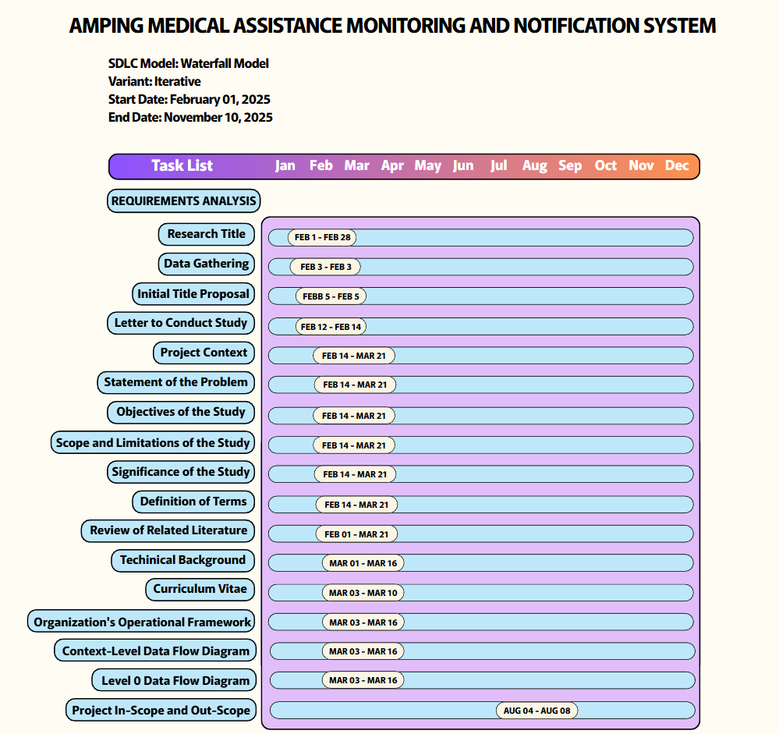**GANTT CHART**

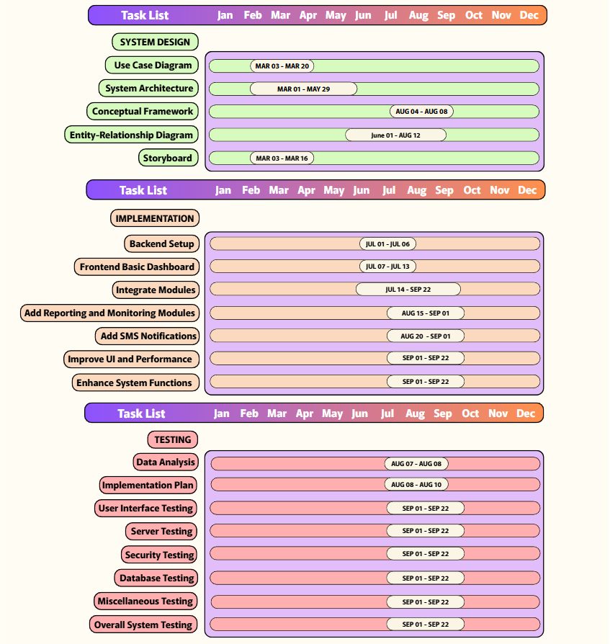

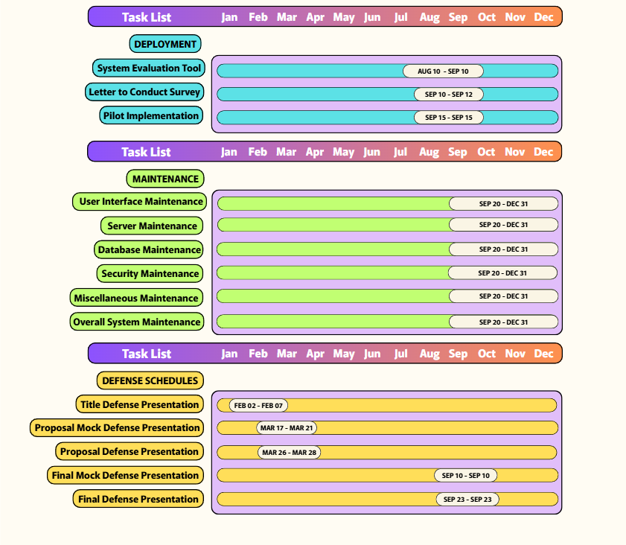

APPENDIX C

**SOURCE DATA**

The data below show the results of the system evaluation conducted in AMPING Office on October 10, 2025. Respondents rated each statement about the system using the 5-point Likert scale where:

5 - Strongly Agree

4 - Agree

3 - Neutral

2 - Disagree

1 - Strongly Disagree

**FUNCTIONALITY**

|  |  |  |  |  |  |  |  |  |  |  |  |
| --- | --- | --- | --- | --- | --- | --- | --- | --- | --- | --- | --- |
| **Statements** | **Respondents** | | | | | | | | | | **Ave** |
| **1** | **2** | **3** | **4** | **5** | **6** | **7** | **8** | **9** | **10** |
| 1. The Guarantee Letter generator created accurate GLs every time. | 4 | 5 | 5 | 5 | 3 | 5 | 4 | 4 | 4 | 4 | 4.3 |
| 1. The SMS notification feature sends reminders and updates correctly. | 4 | 4 | 3 | 4 | 4 | 5 | 4 | 4 | 4 | 3 | 3.9 |
| 1. The Budget Monitoring tool shows the remaining funds clearly. | 4 | 5 | 4 | 4 | 4 | 4 | 3 | 4 | 4 | 5 | 4.2 |
| 1. The Application recording feature keeps applicant and patient details complete. | 4 | 5 | 4 | 4 | 4 | 4 | 4 | 4 | 3 | 5 | 4.1 |
| 1. The system automatically calculates the correct amount of medical assistance based on the tariff list. | 4 | 5 | 4 | 5 | 4 | 4 | 4 | 4 | 3 | 5 | 4.2 |

**USABILITY**

|  |  |  |  |  |  |  |  |  |  |  |  |
| --- | --- | --- | --- | --- | --- | --- | --- | --- | --- | --- | --- |
| **Statements** | **Respondents** | | | | | | | | | | **Ave** |
| **1** | **2** | **3** | **4** | **5** | **6** | **7** | **8** | **9** | **10** |
| 1. The menu and dashboard are easy to navigate. | 4 | 5 | 5 | 5 | 4 | 5 | 4 | 4 | 4 | 5 | 4.5 |
| 1. The labels, buttons, and forms are clear and understandable. | 4 | 5 | 5 | 5 | 4 | 5 | 4 | 3 | 4 | 4 | 4.3 |
| 1. Searching for applicant profiles and applicant entries is simple. | 4 | 5 | 5 | 4 | 4 | 5 | 4 | 3 | 3 | 5 | 3.9 |
| 1. Error messages clearly explain clearly what needs to be fixed. | 4 | 5 | 5 | 4 | 3 | 5 | 3 | 4 | 3 | 5 | 4.1 |
| 1. The overall design of the web pages looks neat and consistent. | 4 | 5 | 5 | 5 | 4 | 5 | 4 | 4 | 3 | 5 | 4 |

**RELIABILTY**

|  |  |  |  |  |  |  |  |  |  |  |  |
| --- | --- | --- | --- | --- | --- | --- | --- | --- | --- | --- | --- |
| **Statements** | **Respondents** | | | | | | | | | | **Ave** |
| **1** | **2** | **3** | **4** | **5** | **6** | **7** | **8** | **9** | **10** |
| 1. The system rarely experiences crashes or stops working. | 4 | 5 | 4 | 5 | 3 | 3 | 4 | 4 | 4 | 5 | 4.1 |
| 1. Once I save applicant or budget data, it stays correct and accurate. | 4 | 5 | 4 | 5 | 4 | 4 | 4 | 4 | 4 | 4 | 4.2 |
| 1. The system recovers quickly after errors or interruptions. | 4 | 4 | 4 | 4 | 4 | 4 | 3 | 4 | 4 | 4 | 3.9 |
| 1. The calculation of medical assistance amounts is always correct. | 4 | 5 | 4 | 4 | 4 | 5 | 4 | 3 | 4 | 4 | 4.2 |
| 1. SMS notifications are always delivered to the correct applicant’s phone number. | 4 | 5 | 4 | 4 | 4 | 4 | 4 | 3 | 4 | 4 | 4 |

**PERFORMANCE**

|  |  |  |  |  |  |  |  |  |  |  |  |
| --- | --- | --- | --- | --- | --- | --- | --- | --- | --- | --- | --- |
| **Statements** | **Respondents** | | | | | | | | | | **Ave** |
| **1** | **2** | **3** | **4** | **5** | **6** | **7** | **8** | **9** | **10** |
| 1. The web pages load quickly when I navigate through the system. | 4 | 5 | 3 | 5 | 4 | 5 | 4 | 4 | 3 | 4 | 4.1 |
| 1. Reports and guarantee letters are generated right away without delay. | 4 | 5 | 3 | 4 | 4 | 3 | 4 | 4 | 4 | 4 | 3.9 |
| 1. The system still works smoothly even when many staff are using it at the same time. | 4 | 4 | 3 | 4 | 4 | 4 | 4 | 4 | 4 | 4 | 3.9 |
| 1. The system quickly saves and updates applications for daily use. | 4 | 4 | 5 | 4 | 4 | 4 | 3 | 3 | 4 | 4 | 3.9 |
| 1. The system updates budget records immediately after every transaction. | 4 | 5 | 5 | 4 | 4 | 4 | 4 | 3 | 3 | 4 | 4 |

**SUPPORTABILITY**

|  |  |  |  |  |  |  |  |  |  |  |  |
| --- | --- | --- | --- | --- | --- | --- | --- | --- | --- | --- | --- |
| **Statements** | **Respondents** | | | | | | | | | | **Ave** |
| **1** | **2** | **3** | **4** | **5** | **6** | **7** | **8** | **9** | **10** |
| 1. The system can easily add or update user roles and permissions. | 4 | 5 | 4 | 4 | 4 | 4 | 4 | 4 | 4 | 4 | 4.2 |
| 1. The system can add or update affiliate partners when needed. | 4 | 5 | 4 | 4 | 3 | 4 | 4 | 4 | 4 | 4 | 4 |
| 1. The system keeps a clear record of previous applications for reference. | 4 | 4 | 4 | 4 | 3 | 4 | 4 | 4 | 4 | 4 | 3.8 |
| 1. The system allows updating tariff lists (medical service prices) when there are changes. | 4 | 5 | 4 | 4 | 4 | 5 | 4 | 4 | 4 | 4 | 4.2 |
| 1. The system enables adding new sponsors or fund sources when needed. | 4 | 5 | 4 | 4 | 4 | 5 | 4 | 4 | 4 | 4 | 4.2 |

APPENDIX D

**EVALUATION TOOL**

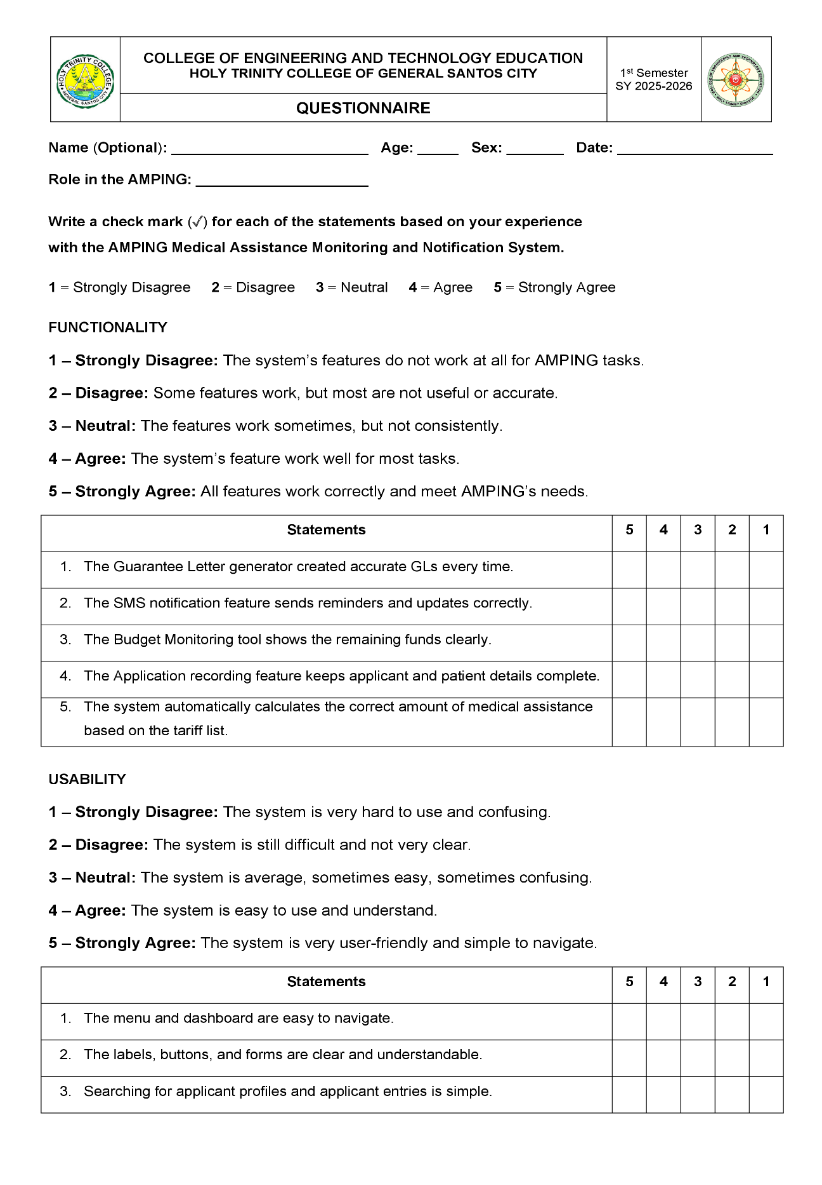

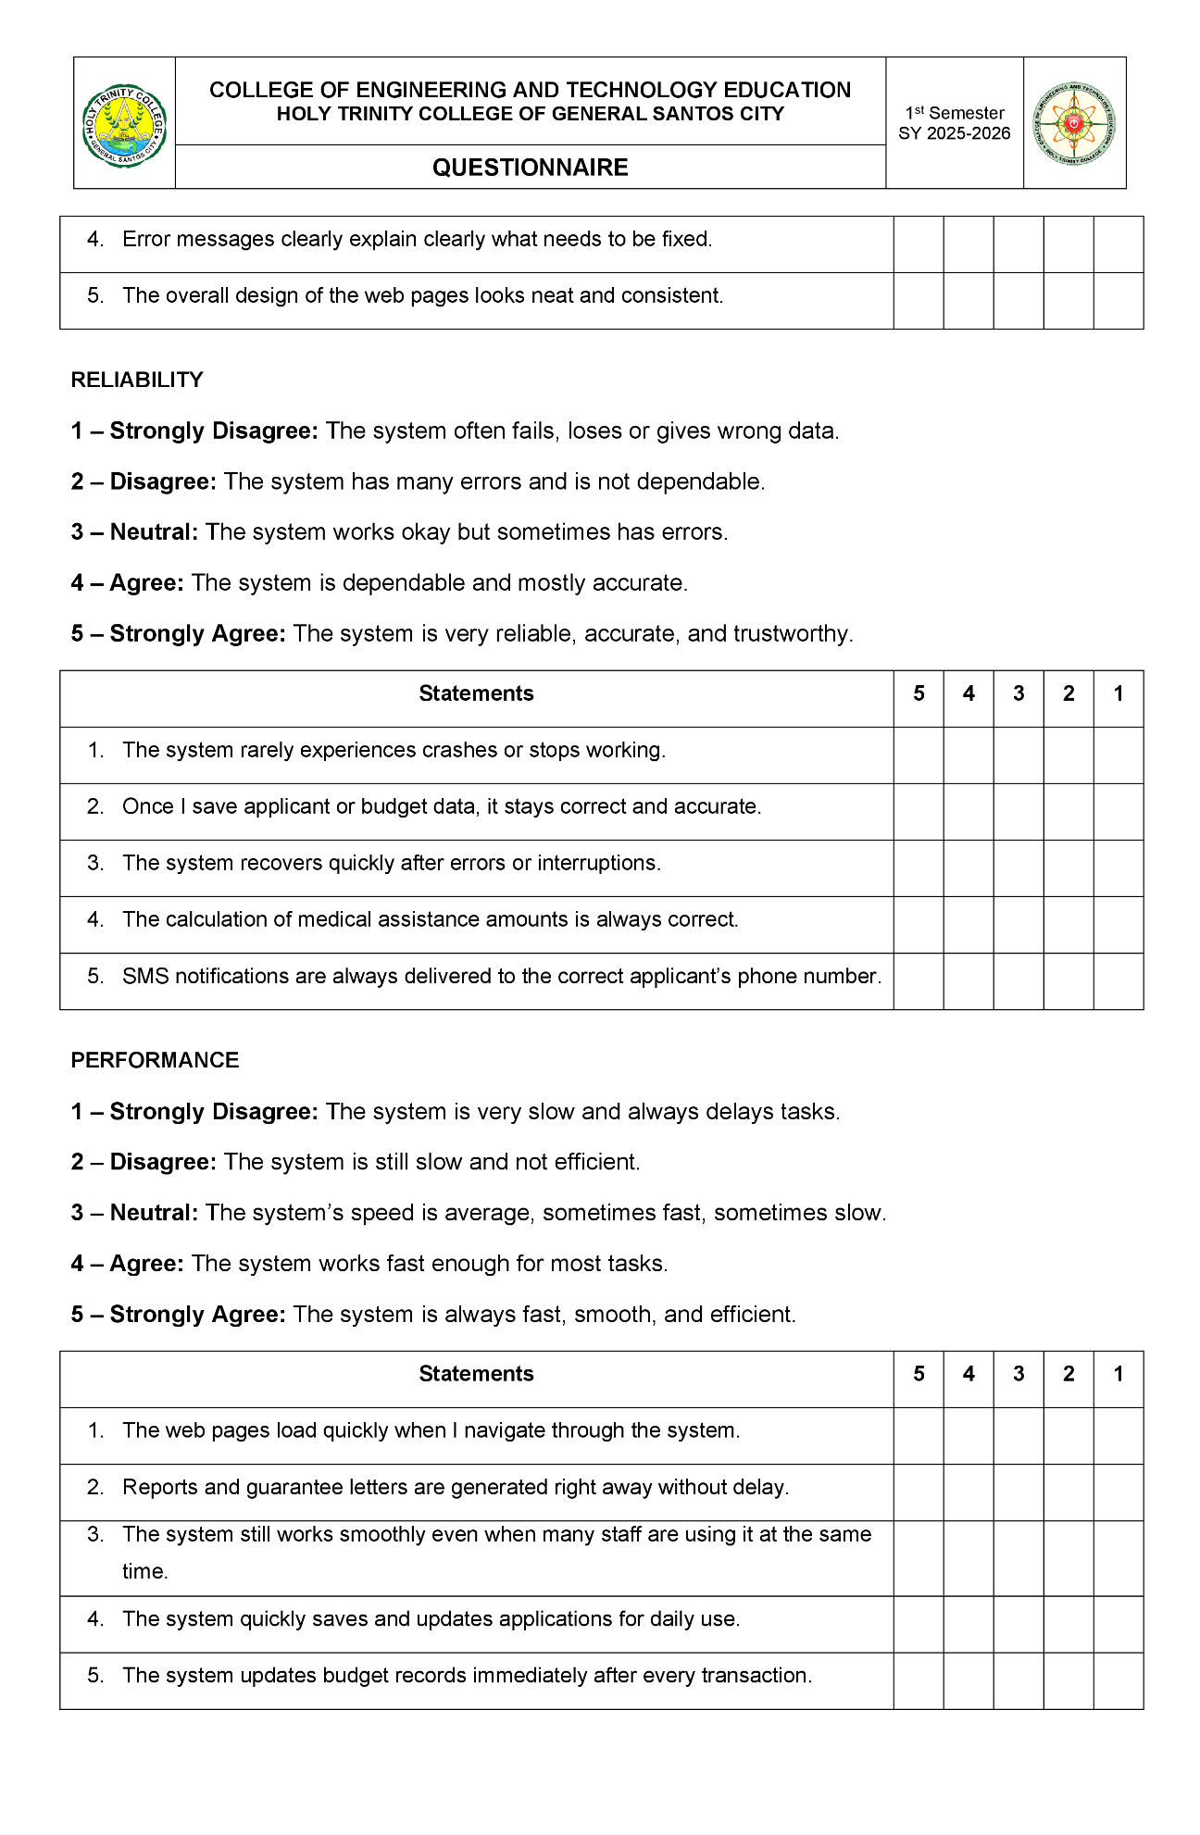

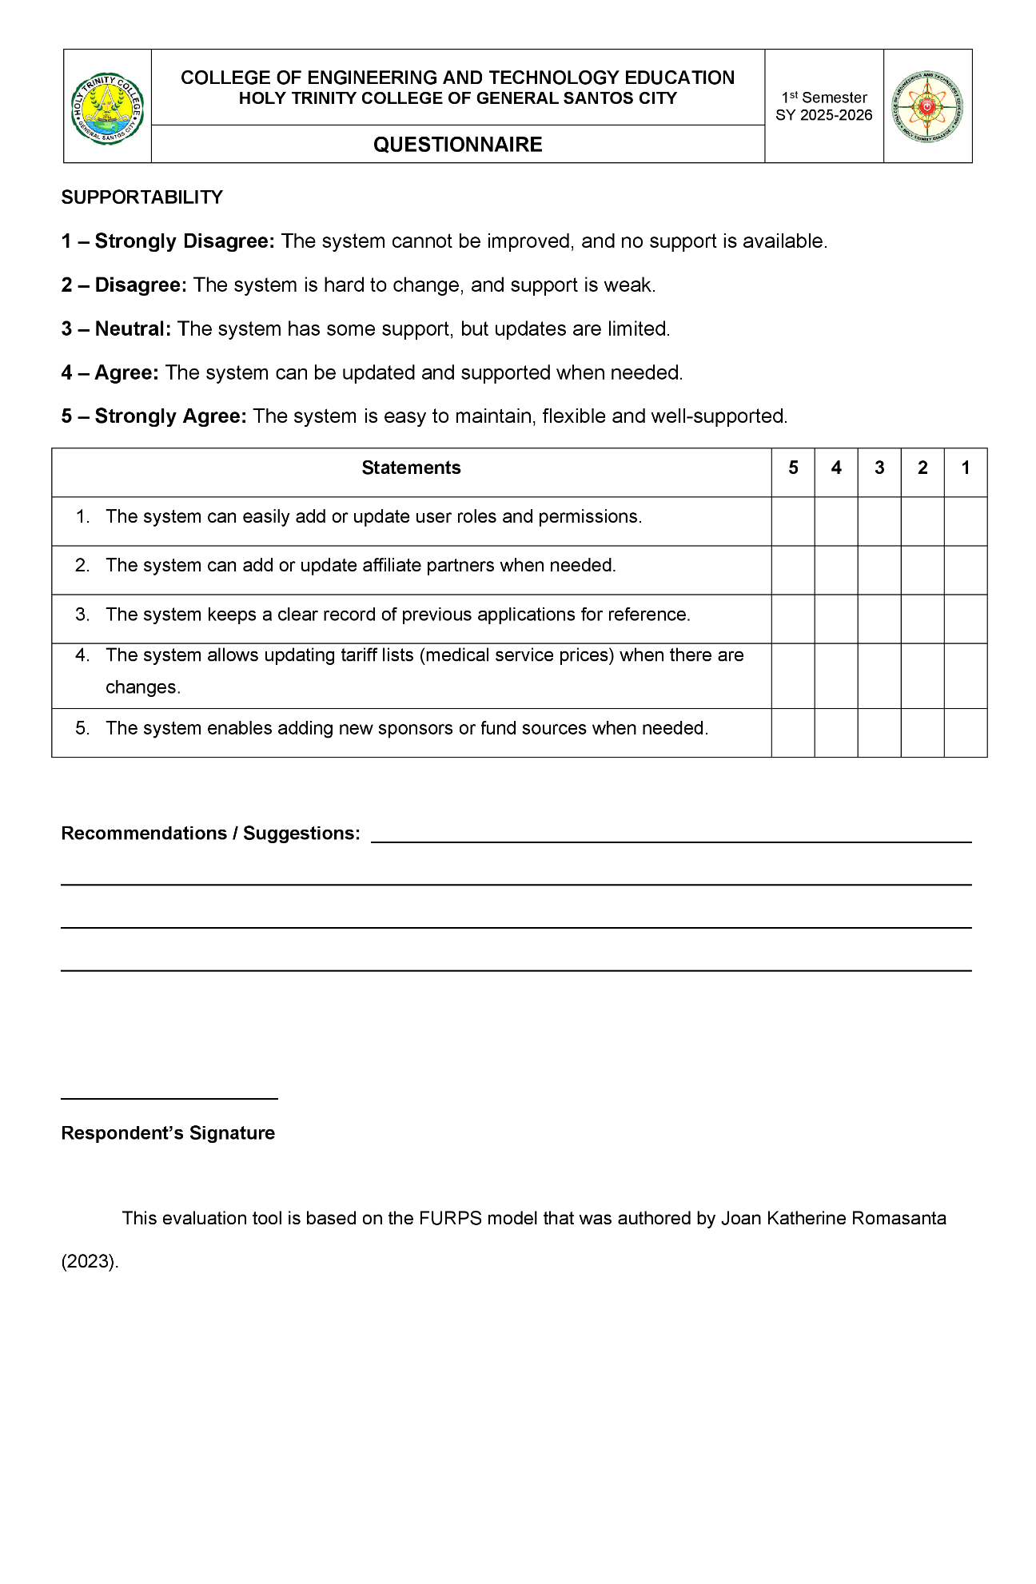

APPENDIX E

**TEST RESULTS**

|  |  |
| --- | --- |
| **Functionality** | **Mean** |
| 1. The Guarantee Letter generator created accurate GLs every time. | *4.3* |
| 1. The SMS notification feature sends reminders and updates correctly. | *3.9* |
| 1. The Budget Monitoring tool shows the remaining funds clearly. | *4.2* |
| 1. The Application recording feature keeps applicant and patient details complete. | *4.1* |
| 1. The system automatically calculates the correct amount of medical assistance based on the tariff list. | *4.2* |
| **Total Mean** | ***4.14*** |

|  |  |
| --- | --- |
| **Usability** | **Mean** |
| 1. The menu and dashboard are easy to navigate. | *4.5* |
| 1. The labels, buttons, and forms are clear and understandable. | *4.3* |
| 1. Searching for applicant profiles and applicant entries is simple. | *4,2* |
| 1. Error messages clearly explain clearly what needs to be fixed. | *4.1* |
| 1. The overall design of the web pages looks neat and consistent. | *4.4* |
| **Total Mean** | ***4.3*** |

|  |  |
| --- | --- |
| **Reliability** | **Mean** |
| 1. The system rarely experiences crashes or stops working. | *4.1* |
| 1. Once I save applicant or budget data, it stays correct and accurate. | *4.2* |
| 1. The system recovers quickly after errors or interruptions | *3.9* |
| 1. The calculation of medical assistance amounts is always correct. | *4.1* |
| 1. SMS notifications are always delivered to the correct applicant’s phone number. | *4* |
| **Total Mean** | ***4.06*** |

|  |  |
| --- | --- |
| **Performance** | **Mean** |
| 1. The web pages load quickly when I navigate through the system. | *4.1* |
| 1. Reports and guarantee letters are generated right away without delay. | *3.9* |
| 1. The system still works smoothly even when many staff are using it at the same time. | *3.9* |
| 1. The system quickly saves and updates applications for daily use. | *3.9* |
| 1. The system updates budget records immediately after every transaction. | *4* |
| **Total Mean** | ***3.96*** |

|  |  |
| --- | --- |
| **Supportability** | **Mean** |
| 1. The system can easily add or update user roles and permissions. | *4.2* |
| 1. The system can add or update affiliate partners when needed. | *4* |
| 1. The system keeps a clear record of previous applications for reference. | *3.8* |
| 1. The system allows updating tariff lists (medical service prices) when there are changes. | *4.2* |
| 1. The system enables adding new sponsors or fund sources when needed. | *4.2* |
| **Total Mean** | ***4.08*** |

APPENDIX F

**SAMPLE GENERATED OUTPUT**

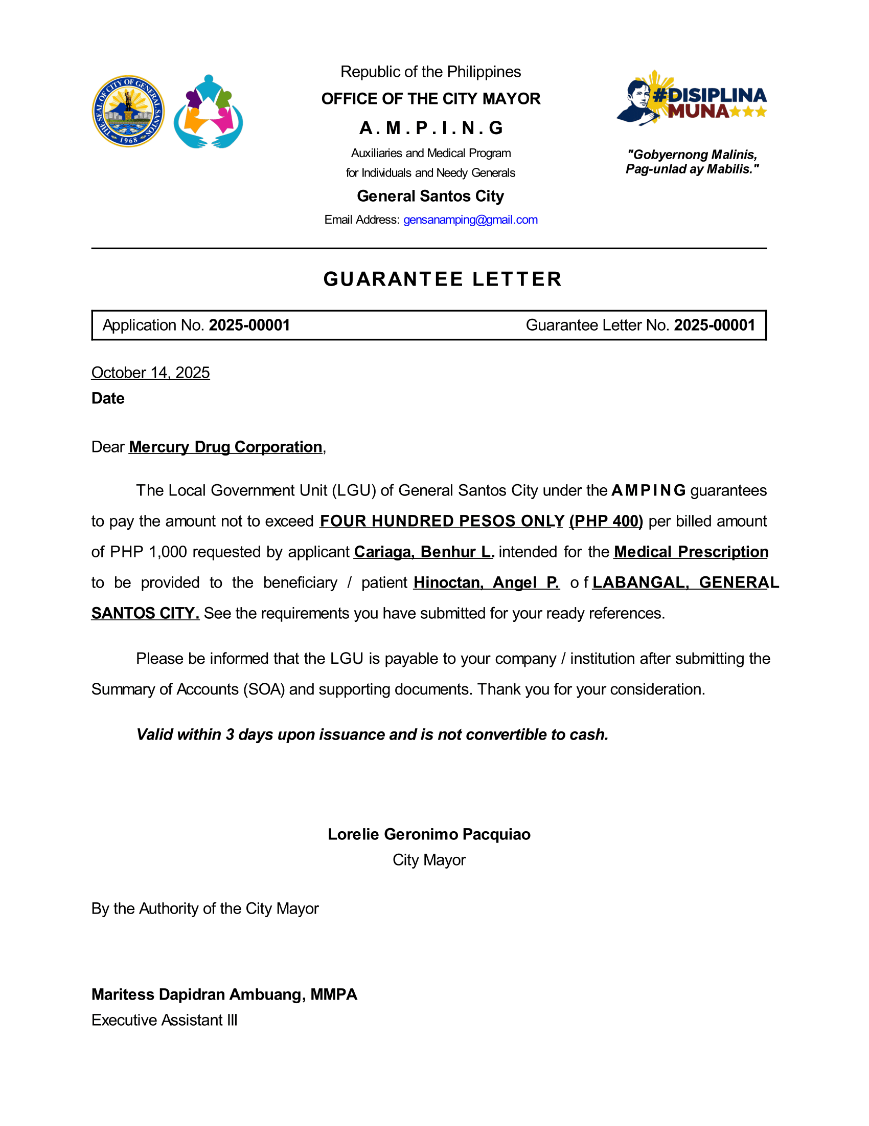

APPENDIX G

**DOCUMENTATION OF DATA GATHERING ACTIVITIES**

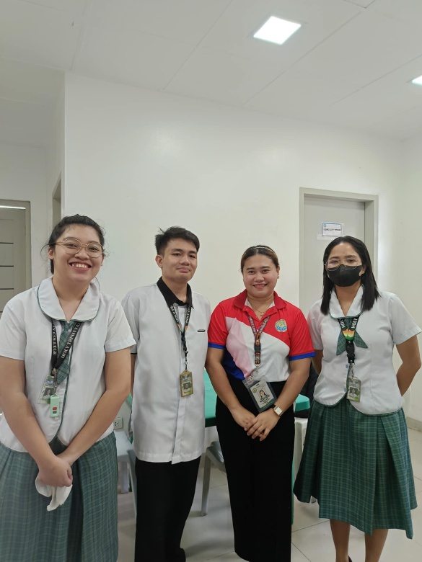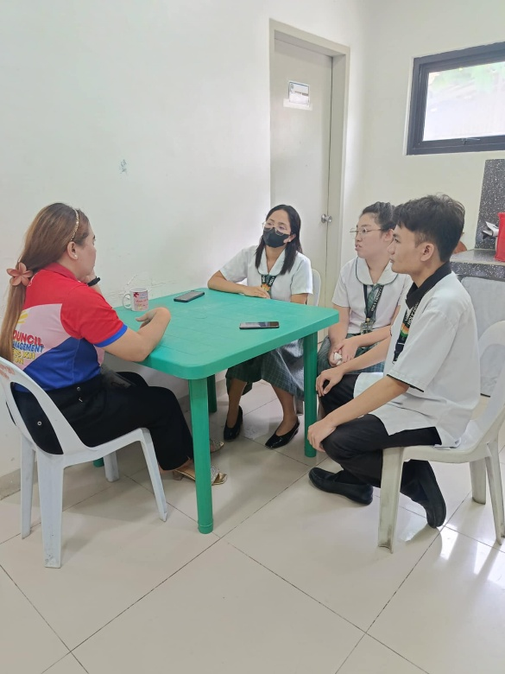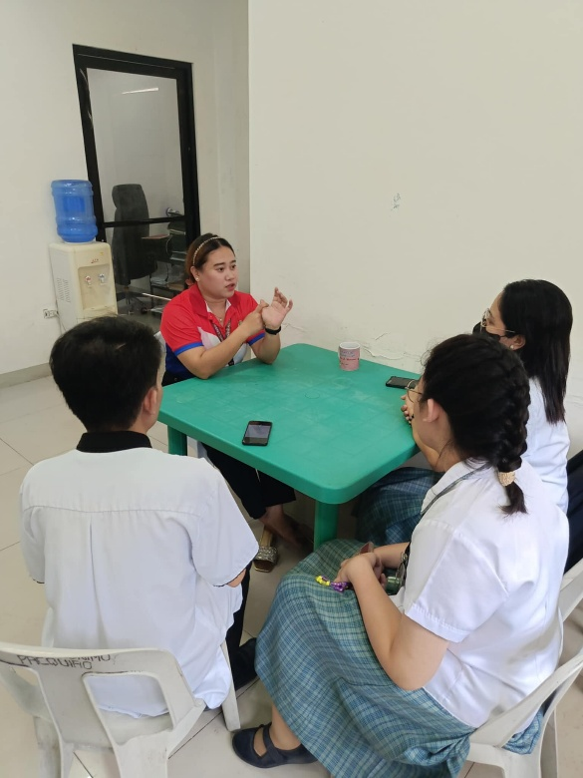

**Interview with Mary Mae C. Pialago, an Administrative Aide III** (**Clerk I**) **in   
CMO-AMPING at GSC Training Center** (**Research Locale**)**, on March 7, 2025**

**DOCUMENTATION OF SYSTEM EVALUATION CONDUCTED**

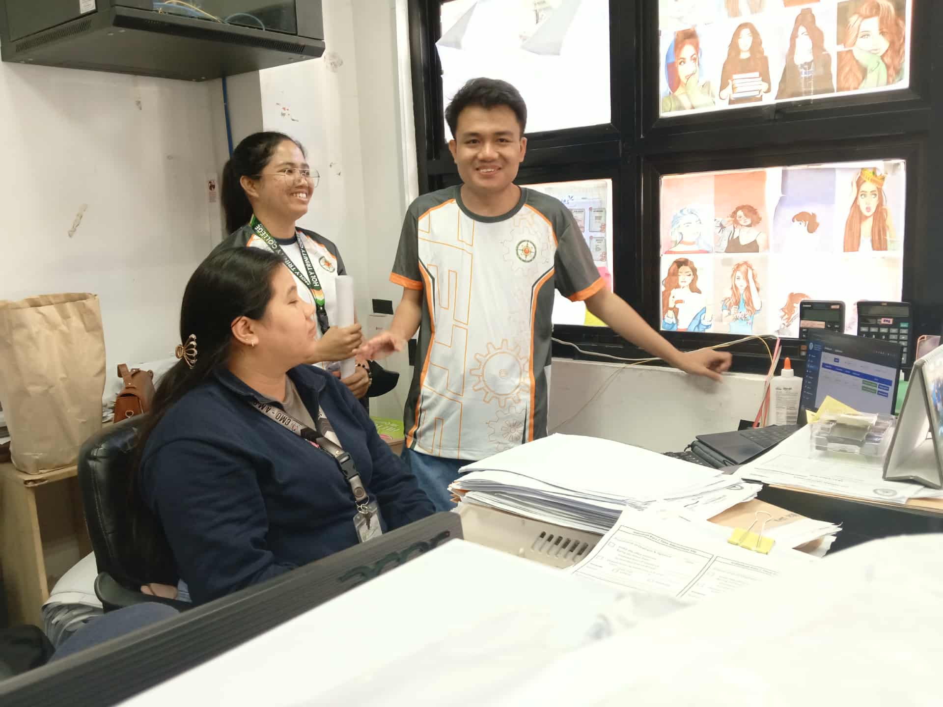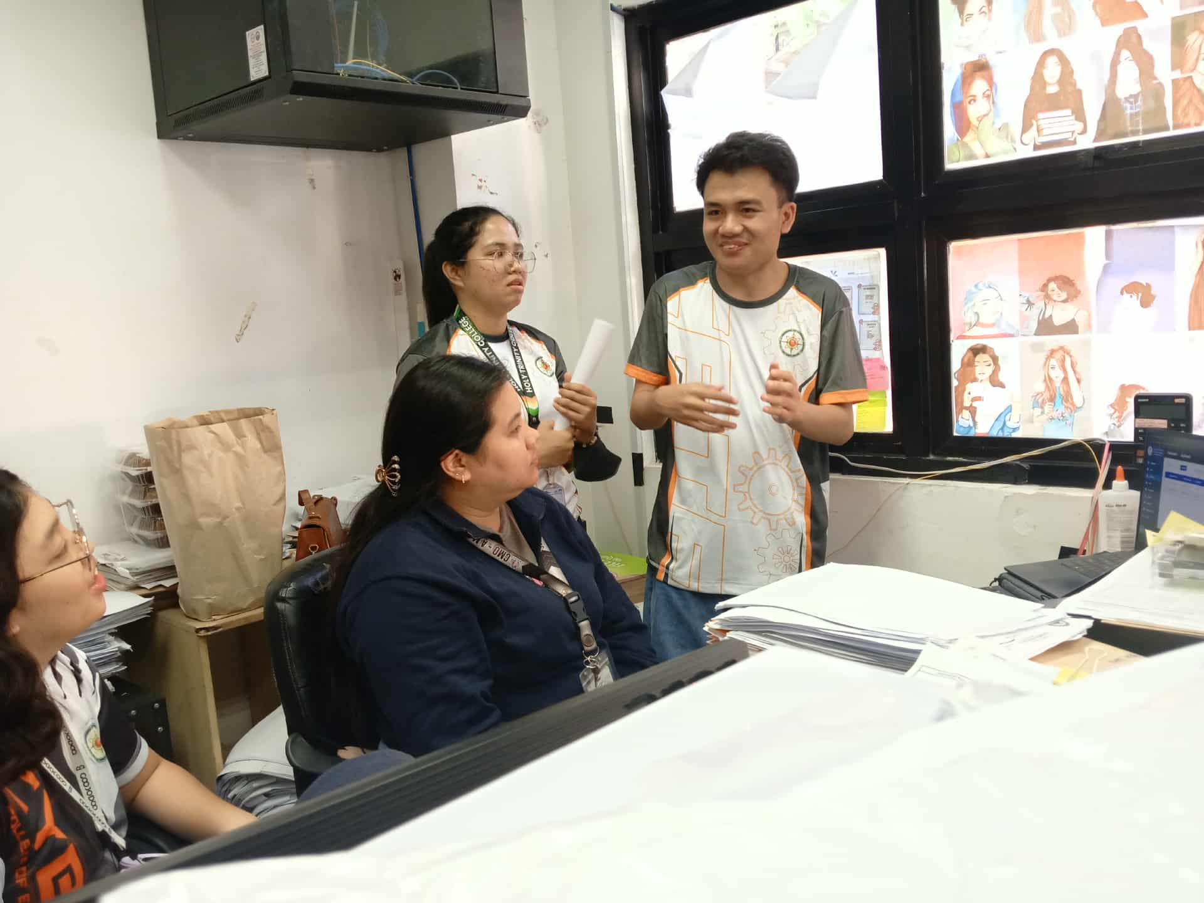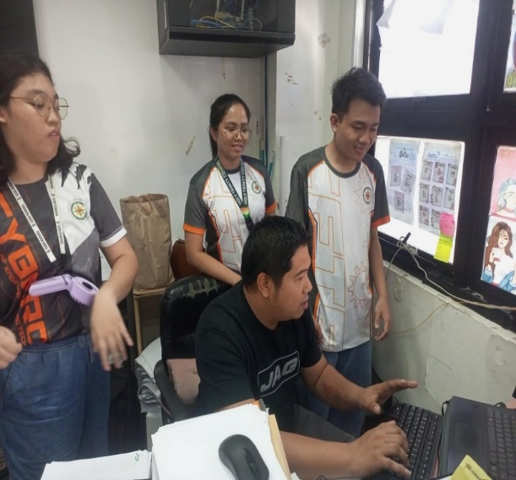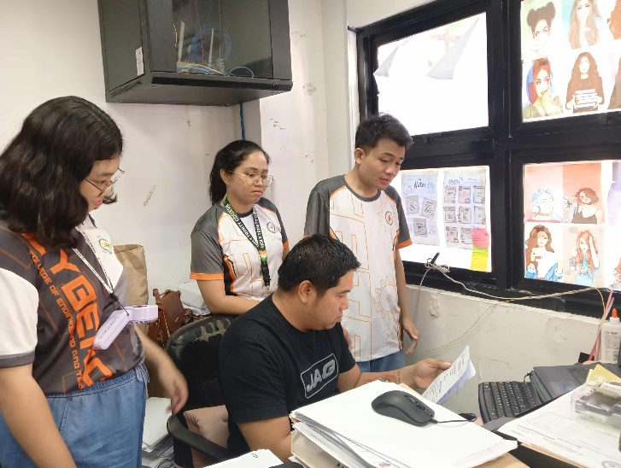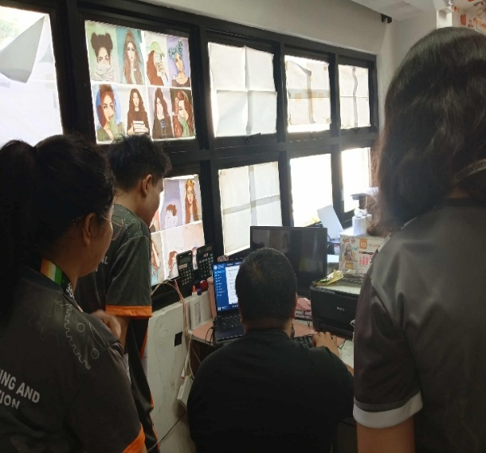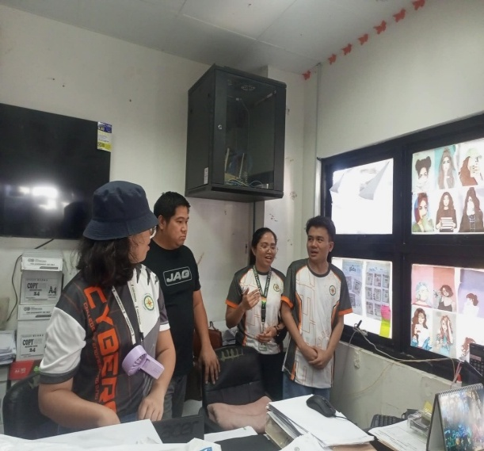

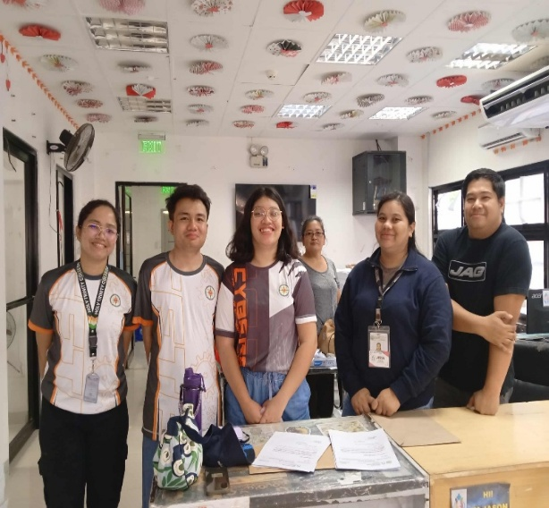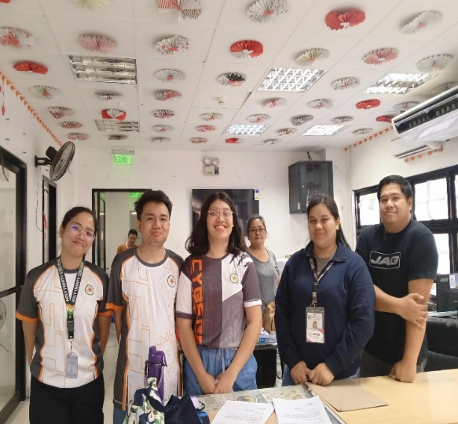**LETTER TO CONDUCT STUDY**

CURRICULUM VITAE

**AIMEE LAURENCE CANDO**



Doña Soledad Subdivision, Brgy. Labangal, General Santos City, South Cotabato

+63 915 751 2177

candoaimeelaurence18@gmail.com

|  |  |  |
| --- | --- | --- |
| ***OBJECTIVE:*** | | |
|  | To obtain an entry-level position as a junior web developer that will  allow me to utilize the skills gained at Holy Trinity College of General  Santos City and build a long-term career in software development. | |
|  |  | |
| ***PERSONAL PROFILE:*** | | |
|  | Age: | 21 |
|  | Birthdate: | November 18, 2003 |
|  | Birthplace: | General Santos City, South Cotabato |
|  | Civil Status: | Single |
|  | Gender: | Female |
|  | Height: | 5’3” |
|  | Weight: | 67 kg |
|  | Religion: | Roman Catholic |
|  | Nationality: | Filipino |
| ***ACADEMIC BACKGROUND:*** | | |
|  | Tertiary: | Holy Trinity College of General Santos City  Fiscal Daproza Avenue, General Santos City  Bachelor of Science in Information Technology  2023 |
|  |  |  |
|  | Secondary: | Holy Trinity College of General Santos City  Fiscal Daproza Avenue, General Santos City  2016 – 2022 |
|  | Elementary: | SPED Integrated School  President Manuel Quezon Ave, General Santos City  2015 – 2016 |
| ***TRAININGS AND SEMINARS:*** | | |
|  | | |
|  | **Cybercrime Awareness Seminar**  March 2023  Anti-Cybercrime Group PRO 12, General Santos City  **Tech Symposium**  May 2024  CETE Department, Holy Trinity College of General Santos City | |
|  |  | |
| ***SKILLS AND ABILITIES:*** | | |
|  | 1. Microsoft Office | |
|  | 1. Java Programming (NetBeans IDE) | |
|  | 1. Web Development (HTML, CSS, JavaScript) | |
|  | 1. Graphic Design (Canva, Piktochart) | |
|  |  | |
| ***PERSONAL SKILLS:*** | | |
|  | 1. Ability to work harmoniously with other members of the team. | |
|  | 1. Ability to provide new ideas and solutions to projects. | |
|  |  | |
| ***CHARACTER REFERENCES:*** | | |
|  | | |
|  | |  | | --- | | **Prof. Meridel C. Ejusa**  Capstone Project Adviser  Holy Trinity College of General Santos City  0921 123 1234  **Prof. Charisse S. Ronquillo, MIT**  CETE Dean  Holy Trinity College of General Santos City  0921 123 1234 | | **Eugene W. Wata, LPT**  JHS Faculty  Holy Trinity College of General Santos City  0951 315 1005  **Honey Mae F. Sanchez, LPT**  HTC-SHS Sports Coordinator/SHS Faculty  Holy Trinity College of General Santos City  0963 291 5358 | | |



**BENHUR L. CARIAGA**

Doña Soledad Subdivision, Brgy. Labangal, General Santos City, South Cotabato

+63 993 959 7683

bencariaga13@gmail.com

|  |  |  |
| --- | --- | --- |
| ***OBJECTIVE:*** | | |
|  | To gain knowledge necessary to obtain entry-level positions in  multiple computing jobs that will enable me to utilize and improve  the skills gained at Holy Trinity College of General Santos City  and build a long-term career in several fields of computing. | |
|  |  | |
| ***PERSONAL PROFILE:*** | | |
|  | Age: | 22 |
|  | Birthdate: | April 2, 2003 |
|  | Birthplace: | Tacurong, Sultan Kudarat |
|  | Civil Status: | Single |
|  | Gender: | Male |
|  | Height: | 5’4” |
|  | Weight: | 50 kg |
|  | Religion: | Roman Catholic |
|  | Nationality: | Filipino |
| ***ACADEMIC BACKGROUND:*** | | |
|  | Tertiary: | Holy Trinity College of General Santos City  Fiscal Daproza Avenue, General Santos City  Bachelor of Science in Information Technology  2022  Mindanao State University -  General Santos City Campus  MSU Road, Calumpang, General Santos City  2021 – 2022 |
|  |  |  |
|  | Secondary: | Notre Dame of Dadiangas University - Main Campus  Marist Avenue, Dadiangas North, General Santos City  2019 – 2021  Shalom Crest Wizard Academy  Salvani Street, City Heights, General Santos City  2016 – 2019  General Santos Hope Christian School  Salvani Street, City Heights, General Santos City  2015 – 2016 |
|  | Elementary: | Notre Dame of Dadiangas University Integrated Basic Education Department - Lagao Campus  Calina Street, Tiongson Exit, Lagao, General Santos City  2009 – 2015 |
| ***TRAININGS AND SEMINARS:*** | | |
|  | | |
|  | **Cybercrime Awareness Seminar**  March 2023  Anti-Cybercrime Group PRO 12, General Santos City  **11th PSITS Regional Convention 2023**  April 2023  KCC Convention Center, General Santos City  **Tech Symposium**  May 2024  CETE Department, Holy Trinity College of General Santos City  **Computer System Servicing NC II**  July 2024 – September 2024  STVET, Holy Trinity College of General Santos City | |
|  |  | |
| ***AFFILIATIONS:*** | | |
|  | | |
|  | **Representative**  2022 – 2023  CETE Department, Holy Trinity College of General Santos City  **Student Member**  July 2024 – September 2024  STVET, Holy Trinity College of General Santos City | |
| ***SKILLS AND ABILITIES:*** | | |
|  | 1. Microsoft Office 2. Java Programming (NetBeans IDE) 3. Web Development (HTML, CSS, JavaScript) | |
|  | 1. Diagram Design (Microsoft PowerPoint) 2. Graphic Design (Microsoft PowerPoint) | |
|  | 1. Audio Editing (Audacity) 2. Video Editing (CapCut) | |
|  |  | |
| ***PERSONAL SKILLS:*** | | |
|  | 1. Ability to work on my own without constant supervision. | |
|  | 1. Ability to go along with other people. 2. Ability to search and identify problems and needs in a situation. 3. Ability to develop and propose plans according to the situation. 4. Ability to sustain determination amidst exhaustion. | |
|  |  | |

|  |  |
| --- | --- |
| ***CHARACTER REFERENCES:*** | |
|  | **Prof. Meridel C. Ejusa** |
|  | Capstone Project Adviser  Holy Trinity College of General Santos City  0921 123 1234  **Prof. Charisse S. Ronquillo, MIT**  CETE Dean  Holy Trinity College of General Santos City  0921 123 1234  **Prof. Leonila R. Juanatas, MIT**  STVET Dean  Holy Trinity College of General Santos City  0921 123 1234 |
|  | **Prof. Abejah Paculdo**  CETE OJT Coordinator  Holy Trinity College of General Santos City  0921 123 1234 |



**ANGEL KATE P. HINOCTAN**

Cientodiez, Maribulan,  
Alabel, Sarangani Province

+63 909 118 3372

angelhinoctan@gmail.com

|  |  |  |
| --- | --- | --- |
| ***OBJECTIVE:*** | | |
|  | To cultivate strong IT skills, particularly programming and networking,  in order to become a skilled employee capable of working on projects  and solving problems in a constantly changing technological world. | |
|  |  | |
| ***PERSONAL PROFILE:*** | | |
|  | Age: | 21 |
|  | Birthdate: | January 14, 2004 |
|  | Birthplace: | General Santos City, South Cotabato |
|  | Civil Status: | Single |
|  | Gender: | Female |
|  | Height: | 5’3” |
|  | Weight: | 57 kg |
|  | Religion: | Roman Catholic |
|  | Nationality: | Filipino |
| ***ACADEMIC BACKGROUND:*** | | |
|  | Tertiary: | Holy Trinity College of General Santos City  Fiscal Daproza Avenue, General Santos City  Bachelor of Science in Information Technology  2022 |
|  |  |  |
|  | Secondary: | Alabel National High School  Alabel, Sarangani Province  2016 – 2022 |
|  | Elementary: | Upper Alabel Elementary School  Alabel, Sarangani Province  2010 – 2016 |
| ***TRAININGS AND SEMINARS:*** | | |
|  | | |
|  | **Cybercrime Awareness Seminar**  March 2023  Anti-Cybercrime Group PRO 12, General Santos City  **Tech Symposium**  May 2024  CETE Department, Holy Trinity College of General Santos City  **12th PSITS Regional Convention 2024**  May 2024  Ramon Magsaysay Memorial Colleges – Koronadal Branch | |
| ***SKILLS AND ABILITIES:*** | | |
|  | 1. Microsoft Office 2. Graphic Design (Canva) 3. Diagram Design (Lucidchart) | |
|  | 1. Web Design (Figma) | |
|  |  | |
|  |  | |
| ***PERSONAL SKILLS:*** | | |
|  | 1. Ability to manage tasks efficiently and perform well under pressure without requiring constant observation. | |
|  | 1. Ability to collaborate effectively with the team and create a positive environment. | |
|  |  | |
| ***CHARACTER REFERENCES:*** | | |
|  | | |
|  | |  | | --- | | **Prof. Meridel C. Ejusa**  Capstone Project Adviser  Holy Trinity College of General Santos City  0921 123 1234 | | **Charisse s. Ronquillo, MIT** | | CETE Dean  Holy Trinity College of General Santos City  0921 123 1234 | | **Elizardo D. Hinoctan**  Barangay Captain  Maribulan, Alabel, Sarangani, Province  0967 596 3439 | | |